Palmar/Plantar Digital Nerve (PDN) Block

Common Conditions Diagnosed:
- “Navicular Syndrome”
- Heel Pain Syndrome
- Wing Fractures of P3
- Subsolar abscess
- +/- Pedal osteitis
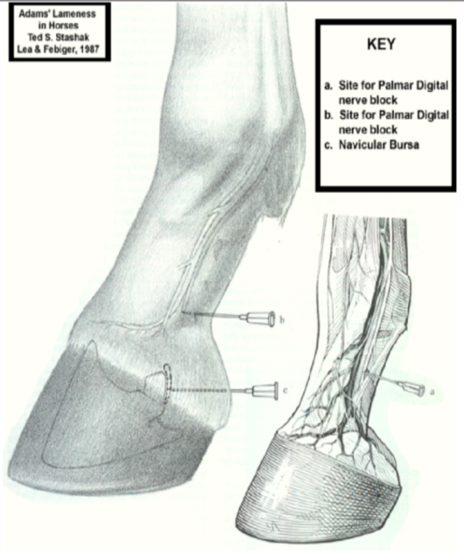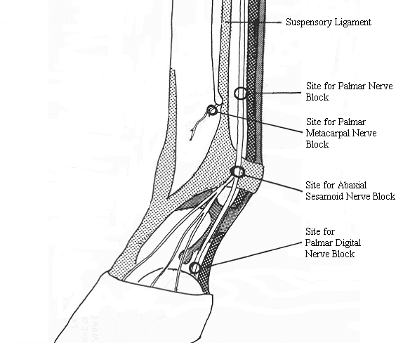

Method:
The medial and lateral digital artery and vein can usually be palpated on the palmar aspect of the pastern by drawing a thumb over the area from medial to lateral. The nerve runs within the bundle of vessels and is the most axial structure (nerve, then artery then vein, going axially to abaxially). A 25G 5/8th inch needle is inserted (pointing distally) at the level of the collateral (ungual) cartilage of the foot (most distal region of nerve palpable) and 1.0-1.5ml of local anaesthetic agent is injected subcutaneously on each side (should see skin bleb form). This is best done with the foot held up.

Region desensitised: Palmar foot (including the navicular apparatus and distal deep digital flexor tendon), distal interphalangeal joint and whole of the sole; skin at the bulbs of the heels, skin on the dorsal aspect of coronary band retains sensation.

