Classified according to:
• The duration from time of trauma (A or C)
• The localization and conformation of the laceration
• The thickness of the lesion (full or partial thickness)

Full thickness lacerations and punctures should be treated as a medical emergency!

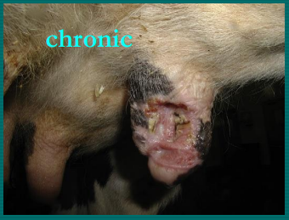
Chronic lacerations must be debrided and treated aseptically with open wound management.

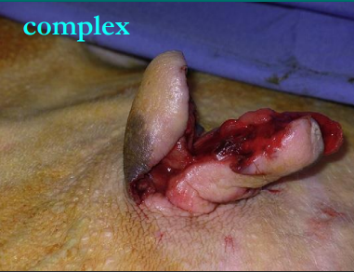
Complex lacerations have a poor prognosis if the teat sphincter is involved. If the teat sphincter is not involved it can be repaired using there 2 simple interrupted sutures for the mucosal and subcutaneous tissue, and near-far-far-near suture for skin layer.

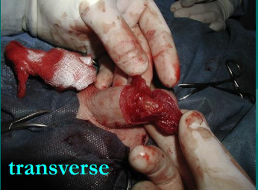
Transverse lacerations have a worse prognosis than longitudinal ones as more blood supply to the teat will be severed.

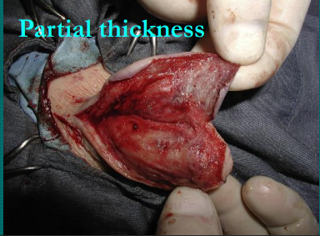
Partial thickness lacerations can be repaired using a walking suture to eliminate dead space in closure.

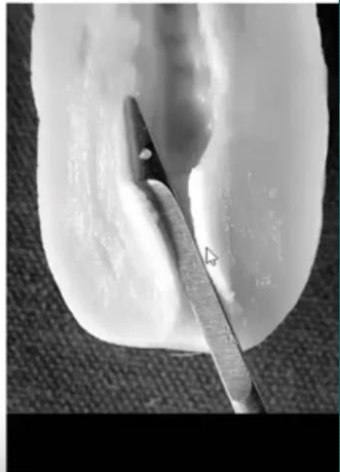
Teat stenosis- hard to remove milk and may have teat fibrosis

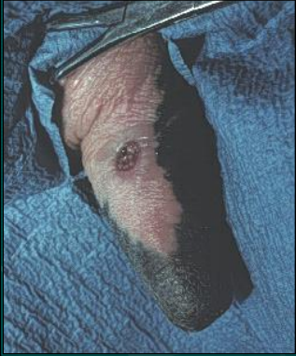
Teat fistula- animal must first be dried off, area around is excised and than sutured in 3 layers as previously mentioned for complex lacerations.

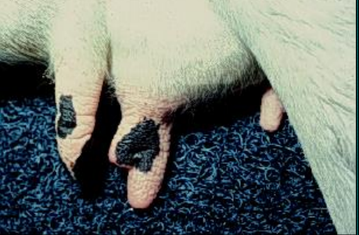
Supernumerary teat- milk escapes through small opening, must be surgically removed for proper milking.

Teat lacerations – Prognosis
- Fresh better than chronic
- Vertical lacerations better than horizontal
- Proximal better than distal
- Sharp better than crushing
- Streak canal involvement decreases prognosis

