Name | Picture | Use | Directions
Alligator Forceps | 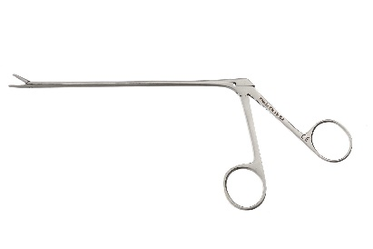 | - Teat Peas may be tissue masses or hematomas  - may be tissue masses or hematomas | Palpated externally to find location of teat pea. Insert the alligator forceps in the closed position then open after passing the teat sphincter close around the pea and the pull out while remaining closed.
Doyen Clamp | 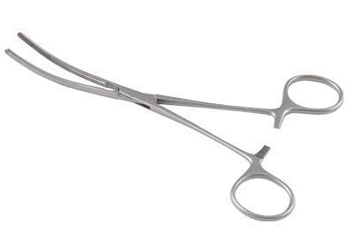 | - Haemostasis of teat during surgical procedures without crushing blood vessels | Clamp is closed at the proximal based of the teat where it begins to widen.
Teat Cannula | 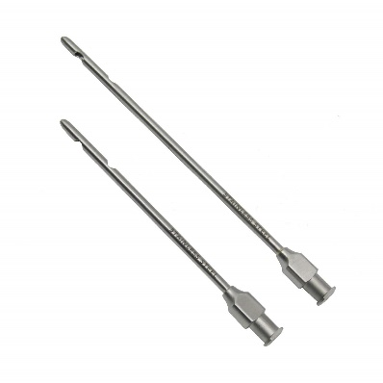  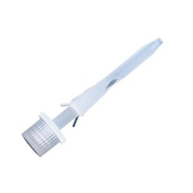  Self-retaining cannula | - To keep injured teat open during milk  - Intramammary infusion | - Cannula is inserted through the teat sphincter before milking.  - For intramammary infusion cannula is inserted and the syringe is attached.  - Self retaining cannula inserted after teat surgery or anything that will cause swelling to keep canal patent while it heals.
Hog’s Tumour Extractor | 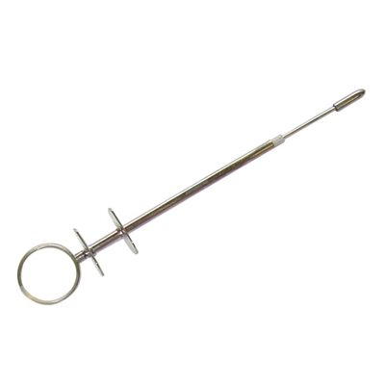 | - Remove tumour or fibrous material from teat canal | The instrument is inserted into the teat canal with the blade concealed and then pressed to expose the blade and rub along canal until tumour is removed. The blade is then concealed by not pressing anymore and then removed from the teat sphincter.
Teat Slitter | 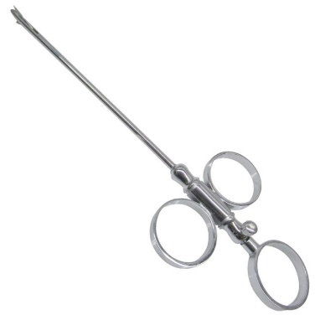 | - Expansion of the teat canal from fibrous tissue | Instrument is slipped into the teat canal and the blade is released by pushing out the ring; the incision is made from the inside out and repeated at a perpendicular angle.
Teat Dilator | 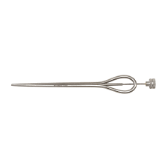 | - Open teat canal | Instrument is inserted into the teat while closed and gradually widened by opening it after being fully inserted.
Litchy teat knife, Bistoury | 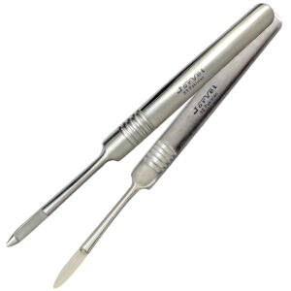 | - Opening stenotic teat | Knife is inserted parallel to the teat sphincter and then ran along the canal in 4 quadrants and pulled out the teat sphincter at a 45 degree angle to run the rounded part along the sphincter to avoid it being damaged after each pull.
Cornell Teat Curette | 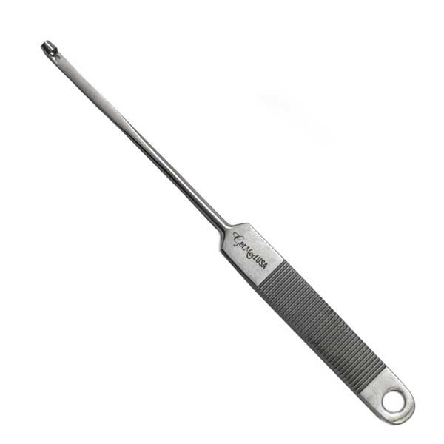 | - Remove obstructions or tumours from teat canal.  - Take biopsies | Insert curette into teat canal so that the loop is above the obstruction and pull it down and out the teat sphincter being careful not to damage it.

