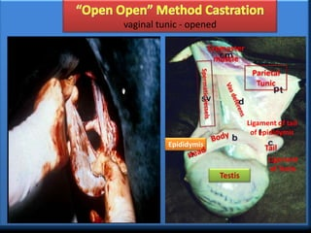

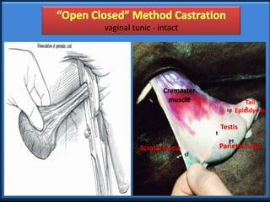

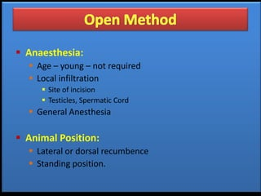

1. Castrating Beef x Dairy Calves, University of Wisconsin-madison

<https://livestock.extension.wisc.edu/articles/castrating-beef-x-dairy-calves/#:~:text=Surgical%20(open)%20castration%20is%20a,this%20area%20fills%20with%20fat>.

1. Castration of calves NADIS

<https://www.nadis.org.uk/disease-a-z/cattle/castration-of-calves/>

1. University of Minnesota, Bovine Castration

<https://open.lib.umn.edu/largeanimalsurgery/chapter/fa-castration/>

<https://youtu.be/aceVekHiWMw>

<https://youtu.be/5UrCHbxTJbA>