***Surgical castration***

Lidocaine can be administered intra-testicularly. Adult pigs are NOT very sensitive to lidocaine with a high dose of 8 mg/kg but neonates will be more sensitive. Meloxicam is secreted through the sows milk so feeding meloxicam to the sow at least 3 hours prior to castration would add analgesia and prevent windup. Typically conducted before weaning, most commonly within the first three days of their life. There are various methods for restraining piglets during castration, such as suspending them by their hind legs using a castration stand or another individual's assistance or placing them in a V-trough. Once the piglet is securely positioned, inguinal and scrotal areas are scrub with a suitable disinfectant. Pressing the scrotum the testes are pushed cranial into the inguinal canal either two vertical incisions or a single horizontal incision is made in the scrotal skin, and the testes are extracted by cutting the spermatic cord using a scalpel or by pulling until the cord tears apart. It's important to note that castration is typically performed without the administration of anaesthesia or analgesia.

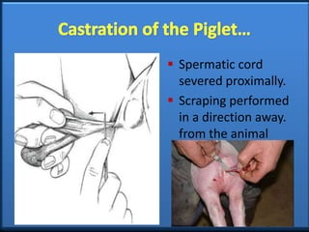

***Immunocastration:***Procedure involving the injection of a protein compound that functions similarly to an immunization. It stimulates the production of antibodies against gonadotropin-releasing hormone (GnRH). This process entails two injections, the first administered 8 to 11 weeks before the pig's scheduled slaughter, and the second given 4 weeks prior to slaughter. Immunocastration leads to a decrease in the production of gonadal steroids, such as testosterone and androstenone. This reduction in hormones is accompanied by an increase in the metabolism of skatole, consequently resulting in a decrease in boar taint. It's important to note that immunocastration is a temporary form of castration. Immunocastration proves effective in reducing sexual and aggressive behaviors exhibited by male pigs, such as mounting, knocking, and fighting, during the period in which the pig is immunocastrated.

**Complications:** Potential complications linked to surgical castration encompass issues such as bleeding, excessive swelling or edema, infections, suboptimal wound healing, and the inadvertent retention of one or both testicles. There is also a suggestion that surgically castrated barrows may experience compromised immune function, resulting in an elevated occurrence of inflammation, pneumonia, and other ailments.

With regard to immunocastration, complications mirror those associated with any injections administered to pigs nearing market weight. These complications include lesions at the injection site, the possibility of needles breaking off inside the pigs, stress imposed on the pigs during handling, and, specifically concerning immunocastration, the risk of accidental self-injection for the stockperson.

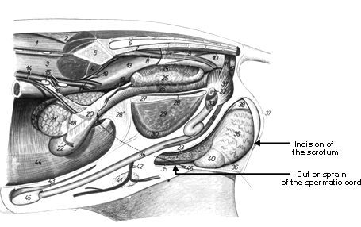

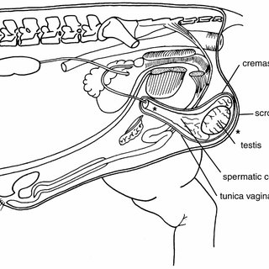

<https://www.avma.org/sites/default/files/resources/swine_castration_bgnd.pdf>

<https://www.thepigsite.com/articles/castration-of-pigs>

<https://www.slideshare.net/vetkkarthik/castration-in-large-animalsppt>