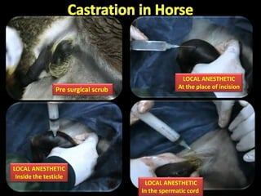

Procedure:  
Make two incisions vertically on each testis about 1 cm from the median raphe.

Grip the testes between your thumb and forefinger and the incised the length of the testis. Continue the incision along the tunica dartos and scotal fascia leaving the common tunic intact.

Apply pressure to extrude the testis by the thumb and forefinger with the testis in one hand removed the sub cutaneous tissue from the common vaginal tunic proximally.

Then incise the common tunic over cranial pole of the testis while one finger is hooked within the tunic to maintain tension to lead to the testis free from the common tunic and spermatic cord separated from the ductus deferens, common tunic and external cremater muscle.

Spermatic cords are emasculated leaving as much as the common tunic as possible.

