Castrating small ruminants, which are essentially young goats, involves employing similar techniques used for calves. The following methods can be used:

1. **Surgical Method:**
   * Use a blade to open the scrotum and remove the testicles through traction, emasculator, or ligature.
2. **Bloodless Methods:**
   * **Bander/Rubber Bands:**

This is a common method but may be less humane for older goat kids as it causes prolonged inflammation. To prepare for the banding process, place an alcohol-soaked band on the prongs of the elastrator. No additional disinfection or cleaning is required as this procedure is bloodless. Securely restrain the kid. With the elastrator's prongs facing the kid, expand the band by squeezing the elastrator. Position the band over the scrotum and testes, close to the body, ensuring that both testes are below the ring. Release the elastrator and remove it from the band, making certain that the band is snug against the body and that the teats are not trapped within it. If the band is improperly placed or if one of the testes is not below the ring, cut off the band and repeat the procedure. In approximately two weeks, the scrotum and testes will desiccate and naturally fall off. If they haven't fallen off by then, perform regular checks for infection and, if necessary, spray them with bactrovet or oxytet.

Procedure:  
Placed the rubber ring around the scrotum with the testicles below it or placed it above the testicles to allow scrotum to fall off within weeks.  
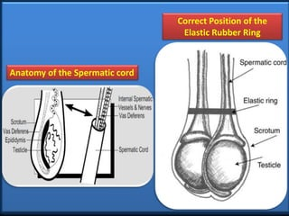

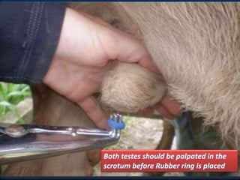

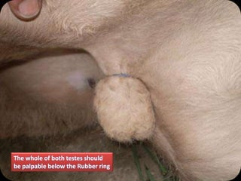

* + **Burdizzos:** Stagger the crushes to avoid issues seen with banders.

The Burdizzo/emasculatome, is an instrument used to crush the spermatic cord, cutting off the blood supply to the testes. This lack of blood supply causes the testicles to atrophy or shrink, while the scrotum remains intact. This method is bloodless and generally less painful than surgical castration. It is most effective when performed on animals up to 12 weeks old, as it allows for the identification of the spermatic cord through palpation.

There are concerns regarding tetanus and provide adequate pain relief. It's crucial to use an appropriately sized Burdizzo, specifically designed for goats rather than one intended for cattle.

It's important to note that this method can be less reliable due to the challenge of accurately identifying the spermatic cords. After the procedure, each goat should be carefully examined, and if there is any break in the skin, a topical disinfectant should be applied.

Here are the steps for using the Burdizzo for castration:

1. Begin by washing and disinfecting the upper portion of the scrotum usually with disinfectant, near where it attaches to the body.
2. With one hand, gently move the testes down into the scrotum.
3. Use your fingers to locate the spermatic cord within the scrotum.
4. Position the Burdizzo clamp over the identified spermatic cord.
5. Spray the area where the clamp is positioned with a topical anaesthetic like Xylocaine.

Position the emasculatome's jaws on the upper section of the scrotum, located just beneath the rudimentary teats, approximately one-third of the way down the scrotum's length. Ensure that when the jaws are closed, they grasp about one-third of the scrotum's width. It's crucial to confirm through palpation that the spermatic cord is within the jaws of the emasculatome before closing them.

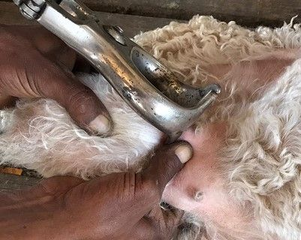

Keep the tool closed for a duration of 15 to 20 seconds, ensuring that you can detect the presence of the spermatic cord within the emasculator's jaws both before and after closure.

Afterward, open the jaws and shift the instrument approximately 2 centimeters lower, then proceed to compress the opposite side of the scrotum. It's crucial to avoid aligning the clamp lines directly across from each other to prevent compromising the blood supply to the scrotum, which could result in complications.

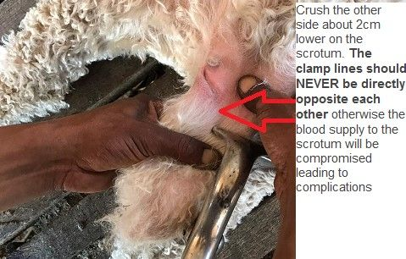

Apply a topical disinfectant or fly repellent spray, such as Supona, to the pressure points. Once the procedure is complete, gently place the kid on its feet to prevent contact with the ground. Allow the kid to reunite with its mother as soon as possible, permitting it to roam freely to a cool, shaded area. Ensure that the goats have access to food and water and provide them with time to recover before returning them to their enclosure.

Regularly examine the kids for any signs of infection or discomfort, and administer appropriate treatment if necessary.

Within approximately two weeks, you'll observe the scrotum starting to shrink and dry up as the blood supply has been cut off. If the scrotum is hanging by a thin thread, it can be carefully severed using a scalpel, followed by the application of topical disinfectant spray.

<https://www.angoras.co.za/article/castration-burdizzo>

Additional info:  
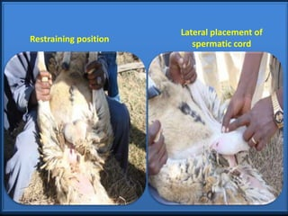

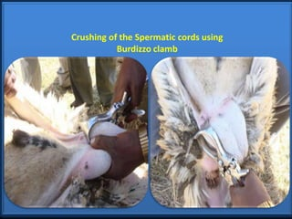

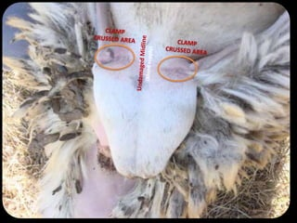

* + **Callicrate Bander:** Suitable for older goats.
  + **Short Scrotum Method:** The scrotum is banded below the testicles, leaving the testicles in place but pushed close to the body to kill sperm through body heat. However, it should be avoided in older animals.

Cryptorchid procedure – the rubber ring is place below the testicles encompassing the scrotum so that the testicles is pushed to the bodywall as testicles at body temperature will lead to infertility but still have the pros of the growth of the male hormones. The scrotum will slough off after a couple of weeks.  
Complication – if the testicles aren’t held high enough against the body the animal may still be fertile.





Goats are highly sensitive to pain, so it's crucial to provide sedation and analgesia. However, they are also sensitive to lidocaine. A recommended maximum dose is 4 mg/kg, and dilution can be used to extend the volume, albeit resulting in a shorter duration of action. For example, lidocaine is typically available as 2% or 20 mg/ml. Preoperative options include flunixin meglumine administered intravenously or meloxicam given orally. Sedative options include xylazine or detomidine, but caution should be exercised with xylazine dosing and these drugs should be avoided in sheep. Alternatively, diazepam/ketamine or midazolam/ketamine can be used.

Given their susceptibility to tetanus, goats should receive a tetanus vaccination.

Many goats are disbudded and castrated within the first week of life. However, for pet goats, delaying castration until later may promote better growth and potentially reduce the risk of obstructive urolithiasis by allowing for greater urethral development.

How to castrate using an elastrator

<https://youtu.be/CWcrFwnTp7U>

Top of Form