***Burdizzo***

The Burdizzo emasculatome employs a crushing method that preserves the scrotal skin without the need for incisions. In this approach, the testicles gradually shrink, but the scrotum remains intact. The emasculatome is applied separately to each spermatic cord at varying positions. This staggered crushing technique ensures that the skin retains its blood supply while still effectively damaging each cord connected to the testicles. Each side is clamped for approximately 10 seconds. The Burdizzo is typically utilized on calves with slightly larger cords that can be easily felt and distinguished.

Figure 


Figure : Use of Burdizzo to castrate and clamp the spermatic cord for our lab

Spermatic cord with the blood vessels leading to the testicles are crushed.

One spermatic cord clipped at a time but both are clipped at two different levels for scrotal sac to receive sufficient blood so wont become gangrenous.

Next leads to thrombus formation in the spermatic vessels (arrest of blood supply and gradual atrophy of the testicles)

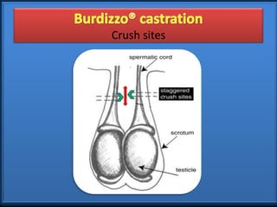

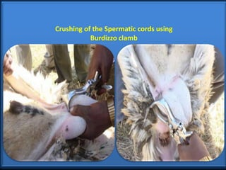

***Banding:***

Banding is a procedure where the testicles are gently pushed into the scrotum, and an elastrator tool is employed to expand rubber rings. These rings are then placed over the base of the scrotum and released onto the cord above both testicles. Subsequently, the scrotum and testicles naturally detach within a span of 30 to 40 days. It's important to note that the use of elastrator bands can potentially lead to tetanus and appears to cause more substantial pain and discomfort, particularly in young calves. Therefore, it is not recommended to use them on older calves, as the compression may not be sufficient to induce ischemia. Additionally, there is a risk of missing a testicle that could slide out of the way, resulting in incomplete castration. In contrast, the Callicrate bander follows similar principles to the elastrator tool but is suitable for use on adult bulls. In general, banding should be avoided in older animals due to the prolonged discomfort it can cause.

***Note: These were not use in the lab so therefore no lab pictures can be uploaded.***

***Emasculator:***

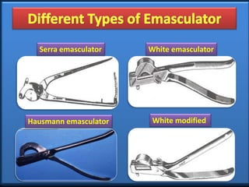

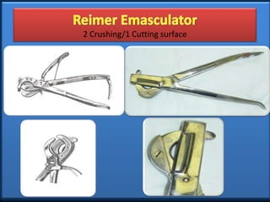

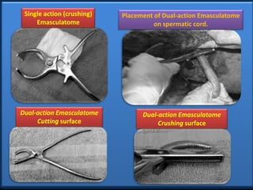

1. The emasculator has two opposing jaws, which are applied to the spermatic cord on either side of the scrotum or testicles.
2. When the emasculator is clamped shut, it crushes the spermatic cord, effectively stopping the blood flow to the testicles.
3. Simultaneously, the emasculator has a cutting mechanism that severs the spermatic cord above the crushing site, allowing the testicles to be removed.
4. With the blood vessels sealed, there is minimal bleeding during and after the procedure.

The emasculator method is considered a humane and efficient means of castration, as it provides the benefits of both crushing and cutting in a single step. It minimizes the risk of bleeding and infection compared to some other methods, and it is often preferred for larger animals like cattle and horses. However, it's essential to use the emasculator correctly and ensure the well-being of the animal during and after the castration procedure.