**DISTAL PARAVERTEBRAL NERVE BLOCK**

Desensitizes spinal nerves T13, L1 & L2.

Location: The dorsal ventral rami of spinal nerves T13, L1 & L2 are desensitized at the distal ends of L1, L2 & L4.

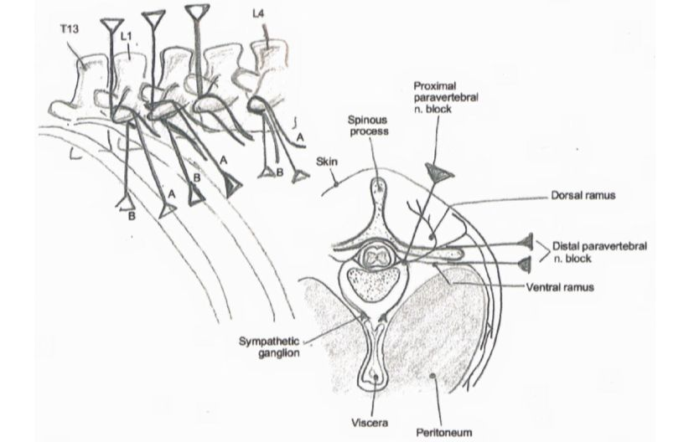

Procedure:

* The injection site is palpated, located, shaved and swabbed.
* Insert an 18 gauge long needle ventral to the transverse process of L1 and inject lidocaine in a fan shaped pattern.
* Redirect the needle dorsally to the transverse process in a caudal direction and inject more lidocaine in a fan shaped pattern.
* Repeat this process for the transverse processes of the 2nd and 4th lumbar vertebrae.

Indication that the block was successful would be the same as seen in proximal paravertebral nerve block.

Table showing advantages and disadvantages of the techniques between proximal and distal paravertebral nerve blocks.

|  |  |  |
| --- | --- | --- |
| Techniques | Advantages | Disadvantages |
| Proximal Paravertebral | Small dose of analgesic  Wide and uniform area of analgesia  and muscle relaxation,  Minimal intra-abdominal pressure Increased intestinal tone and motility  Absence of local analgesic from the  operative wound margins | Technical difficulty  Arching up of the spine due to  paralysis of the back muscles.  Risk of penetrating vital  structures such as the aorta and  thoracic longitudinal vein on  the left side and the caudal  vena cava on the right side. |
| Distal Paravertebral | The use of more routine size  needles, no risk of penetrating a  major blood vessel.  Lack of scoliosis minimal  weakness in the pelvic limb and  ataxia. | Larger doses of anesthetic are  needed.  Variation in efficiency exists,  particularly if the nerves vary  in their anatomical pathway |