RESTRAINT METHODS USED
Halter and lead rope | Used to tie animal to post and to easily maneuver the animal.  Kept the animal secured in one place to give injections. | 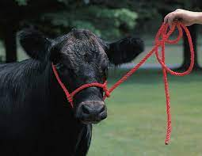
Lateral recumbency | Allowed for better positioning of the animal for the procedure, making it easier to work on.  At times the animal was turned in sternal recumbency and the rumen was massaged to prevent bloat. | 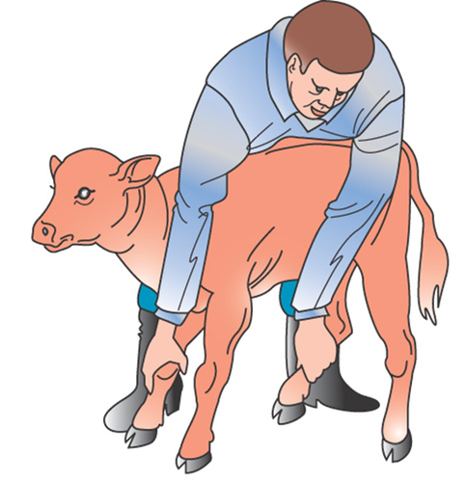  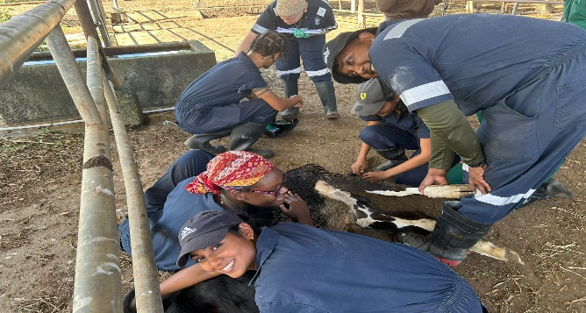
Use of knots (Tom’s fool) | If animal is uneasy and there is movement and kicking, the legs of the animal can be further restrained using Tom’s fool knot when in lateral recumbency. | 