Intra-operative Complications with Dehorning

- Hemorrhaging: Excessive hemorrhaging can occur due to improper technique or due to an underlying condition within the animal. To correct use of cauterization and hemostasis. (Use of cautery iron, hemostatic powders, cotton gauges etc.)
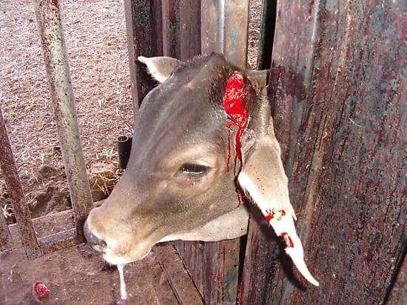
Picture showing bleeding after dehorning.

- Improper setting of Gigly wire at the base of the horn: Leading to the removal of not enough tissue at the base allowing possible re-growth of horn can occur. It is also important to maintain cutting at the angel of the horn to prevent this as well and to achieve a clean cut.
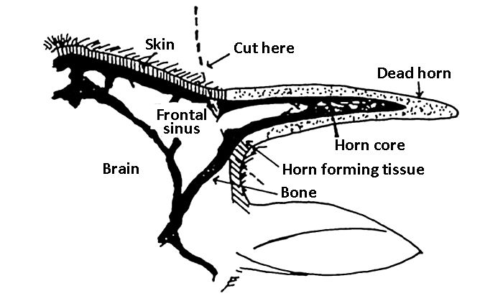
Picture showing the margins to be cut when dehorning.

