MEDICINE APPLICATOR | Pellet applicator & Bolus gun- administer bolus and tablets
 |  | 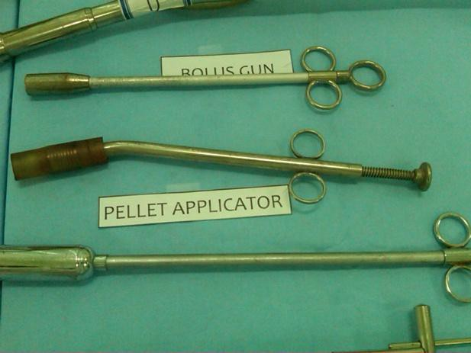
 | Drencher- for oral fluids and drug application | 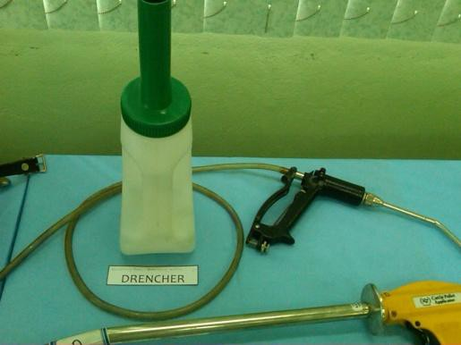
 | Drench gun - used to administer liquids | 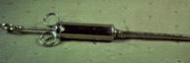
 | Balling gun - used to administer pills

