HOOF TRIMMING CARE | Hoof clipper | 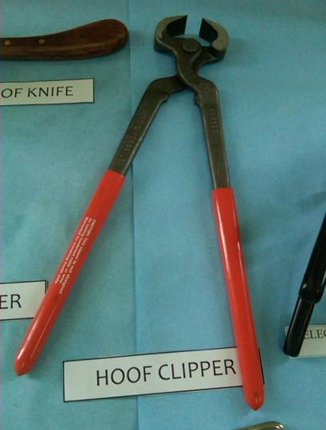 | SEE VIDEO FOR USE AND TECHNIQUE
 | Hoof pick | 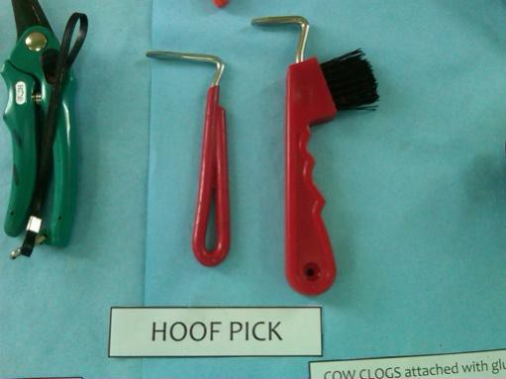 | SEE VIDEO FOR USE AND TECHNIQUE
 | Hoof tester | 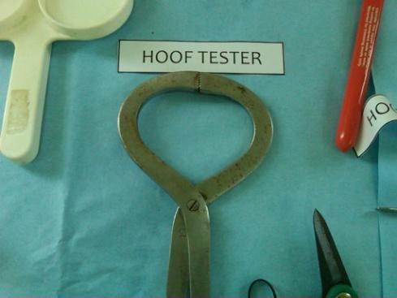 | SEE VIDEO FOR USE AND TECHNIQUE
 | Hoof knife | 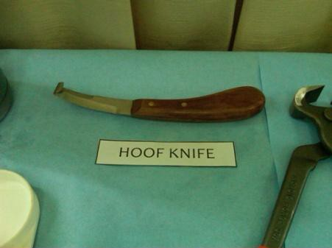 | SEE VIDEO FOR USE AND TECHNIQUE
 | Rasp | 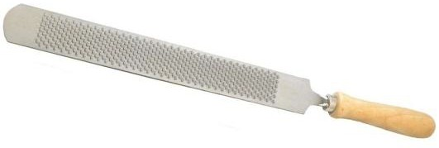 | SEE VIDEO FOR USE AND TECHNIQUE

