PROPER NAME/ PICTURE | INDICATION FOR USE | PROPER TECHNIQUE
Krey Hooks  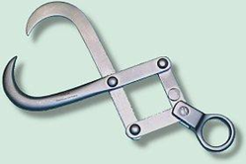 | Dead feotus in large animal medicine | Hook parts of the feotus to make accessibility easier through the vagina
Calf Puller & Jack  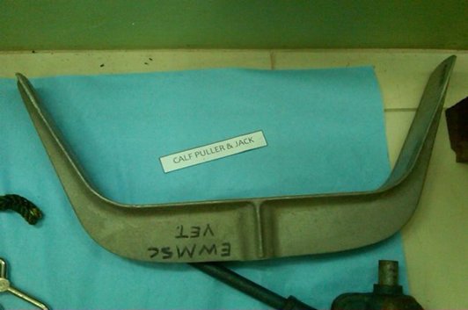 | Dystocia | See attached video
Calving chains and hooks  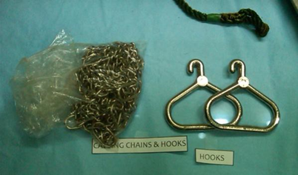 | Dystocia | Applied on the fore limbs, joint to joint on the calf. Chains are then pulled and the calf is guided out of the vagina.
Calving Ropes  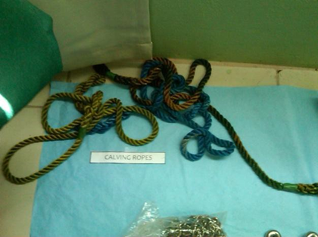 | Dystocia | Same as above but used in small ruminants as well.

