PROCEDURE FOR ENTEROTOMY
- A mid-line abdominal incision is made
- Intestines are exteriorized and observed for presence of foreign body.
- The location of the foreign body is then identified and isolated
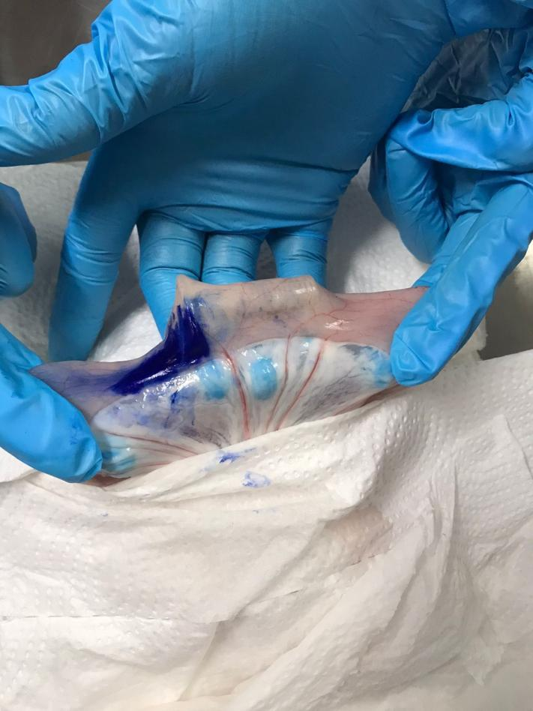
Picture showing foreign body identified and isolated.
- Laparotomy sponges are then used to to further isolate the area of interest by placing the section over the sponges.
- The intestinal contents are then gently milked away from the isolated section and the intestines are held off/occluded either with an assistant’s fingers (digital clamping)or with atraumatic Doyens intestinal forceps.
- A full thickness stab incision is then made into the lumen of the intestine just distal/proximal to the foreign body (on the anti-mesenteric side)
- A longitudinal incision on the aborral bowel portion of the intestine is then made.
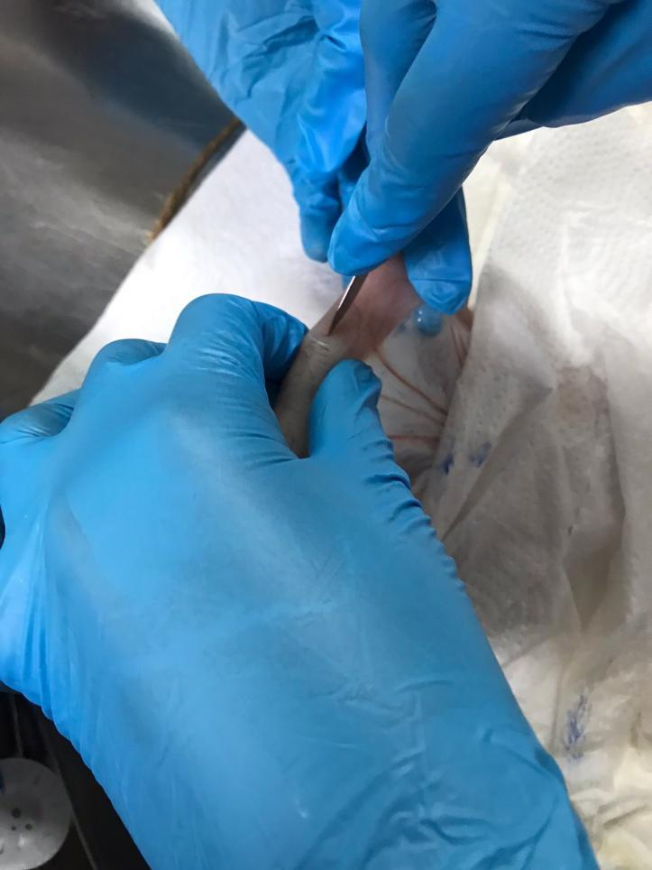
Picture showing first incision being made with scalpel (distal/proximal to the foreign body)
- The incision is lengthened with scissors to allow adequate removal of the foreign body without tearing the intestinal tissue.
- The foreign body in then grasped with tissue forceps (ensuring not the grasp intestinal tissue) and foreign body is gently removed.

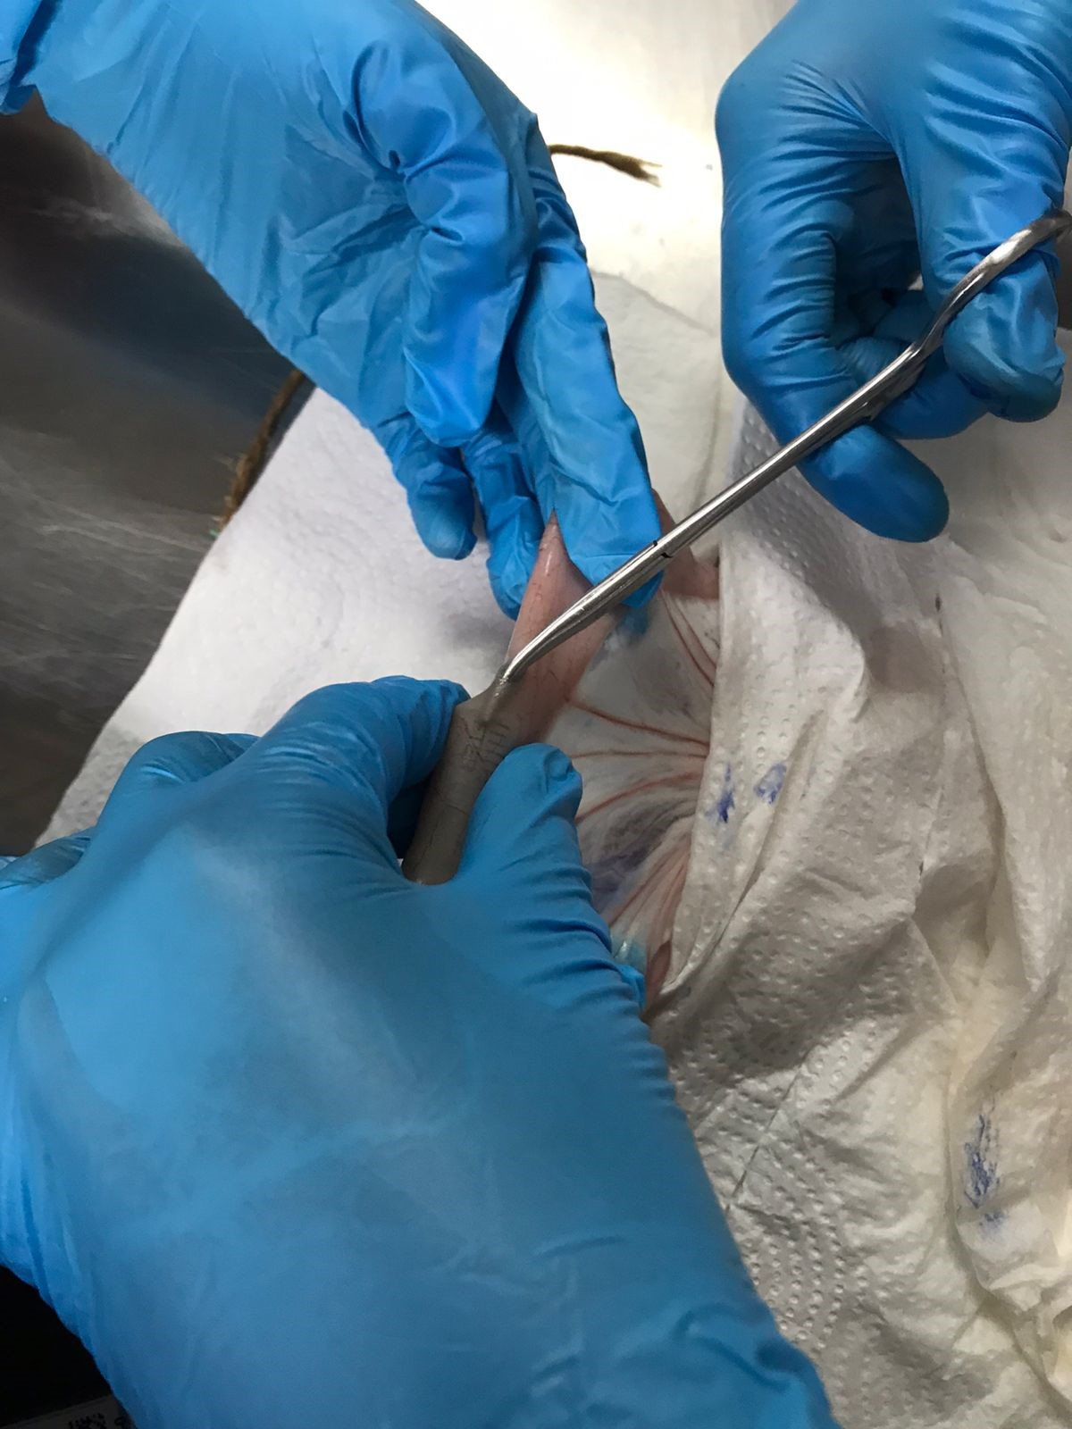
Picture showing tissue forceps being inserted into the incision to grasp the foreign body
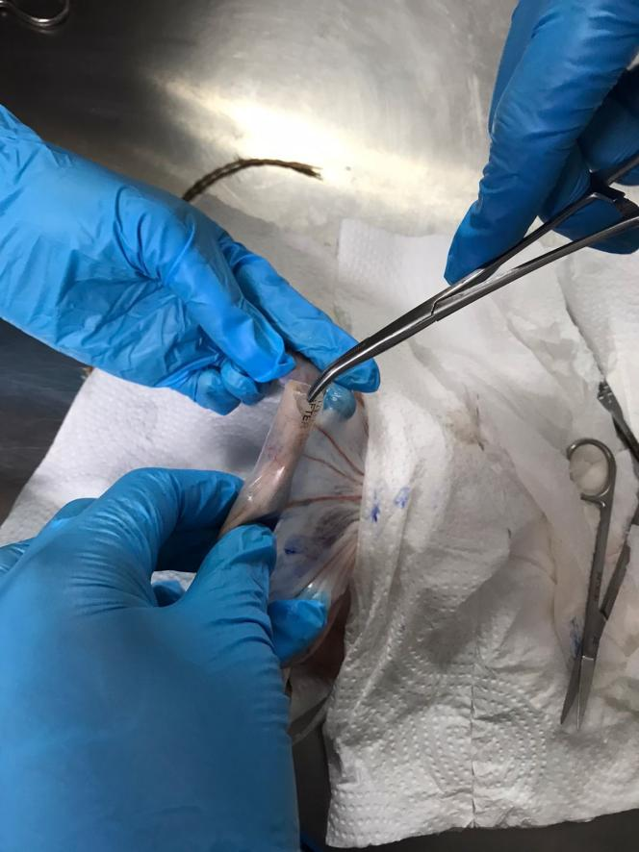
Picture showing foreign body grasped and being removed from the intestine
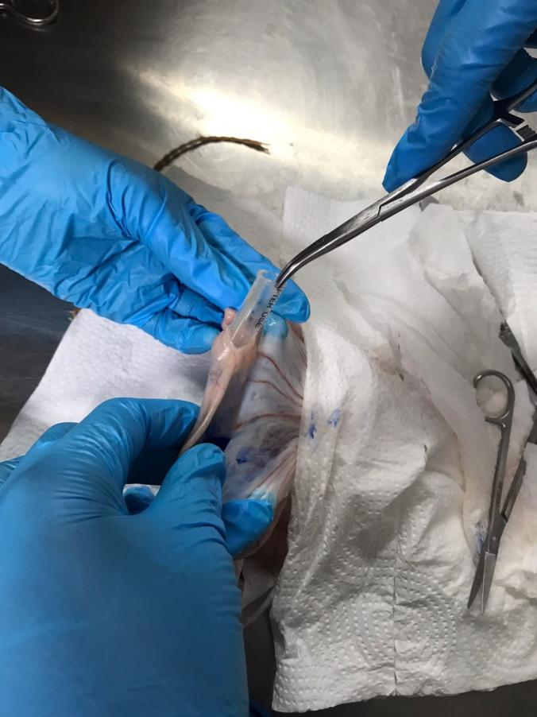
Picture showing most of foreign body removed from the intestine
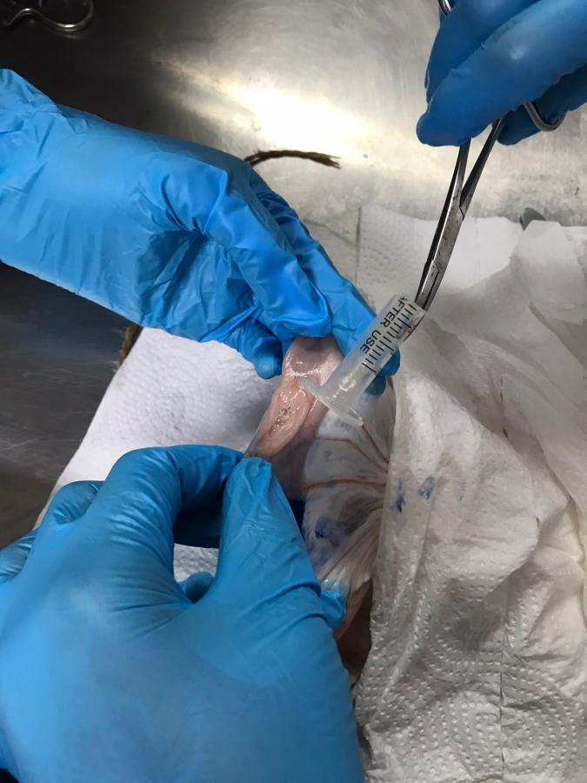
Picture showing entire foreign body removed from intestine

- For biopsies: the tissue can be grasped with the atraumatic Debakeys forceps and a narrow stip of intestinal tissue is removed on the anti-mesenteric side.
- To close the incision, absorbable suture material is used and the incision is closed with a simple interrupted appositional pattern.
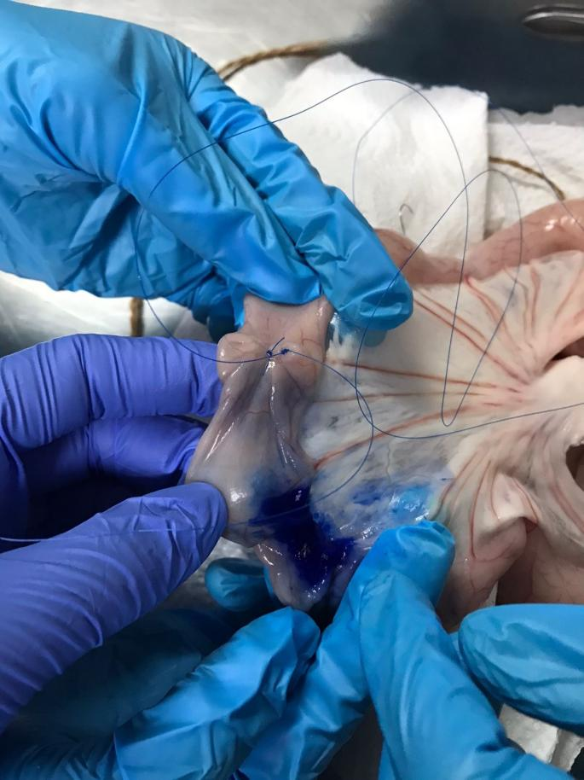
Picture showing first interrupted suture placed (appreciate longitudinal and transverse incisions joining)
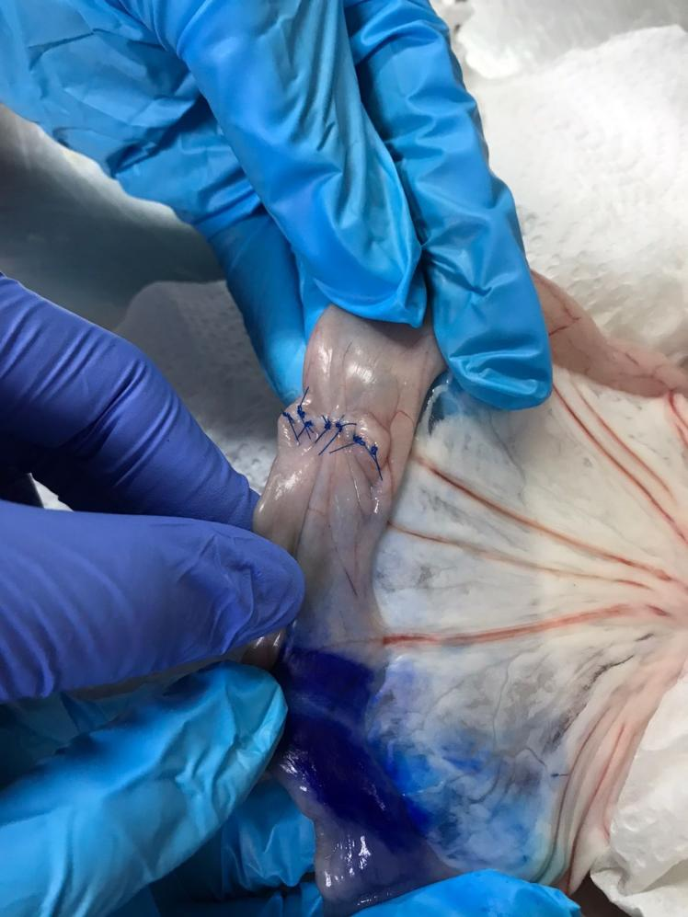
Picture showing incision closed with simple interrupted appositional pattern
- After closing the incision, a leak test (see video) is performed by injecting fluid (saline) into the intestine about 1cm away from the closed incision, and allowing it to fill up and observe for any signs of leakage. If leakage is observed, another continuous suture it to be placed at the area of leakage.
- Once no leakage is observed, the clamps are then removed from both sides of the intestine.

