INTESTINAL SURGERY
Post Operative Measures


Signalment: 20-month-old 400 kg intact Dairy Cow

Post Operative Medications:

Drug | Dose | Frequency | Withdrawal Time | Indicated Use
Flunixin | 2.2mg/kg = (2.2x 400 / 50)  =17.6ml | Once a day for Three (3) days | 4 Days | NSAID In Pain management and relief.
PenStrep long acting | 20,000IU/ kg = (20000x 400/ 200,000) = 40ml | ANTIBIOTICS SHOULD BE DISCONTIINUED WITHIN 2-6 HOURS OF SURGERY UNLESS PERITONITIS IS PRESENT.  In Peritonitis Cases or complications requiring antibiotics: Every 2 days for 3 rounds of treatment. | Meat: 30 days  Milk: 5 days | In infections or extended contaminated open surgeries to reduce infection risks post op.

What are some of the Post Operative complications of Intestinal Surgery?

- Peritonitis - Peritonitis occurs in 13 to 20% of the cases.
- Stenosis
- Perforation
- Leakage – May occur within 24 hours of surgery because of nonviable tissue or inappropriate surgical technique. I
- Ileus
- Recurrence
- Shock
- Short Bowel Syndrome
- Death
Management
- Ensure that the animal is housed in proper conditions, in a clean, cool, and dry environment to reduce stress and promote recovery.
- The surgical wound should be monitored and cleaned using aseptic solution and kept dry. The wound is checked regularly to determine if the wound is healing properly and there are no signs of infection.
- The animal should have access to small amounts of water 8-12 hours after the procedure and the diet should consist of bland food that is low in fat as soon as the animal has not been observed vomiting 12-24 hours after surgery.
- -Provide analgesics as needed.
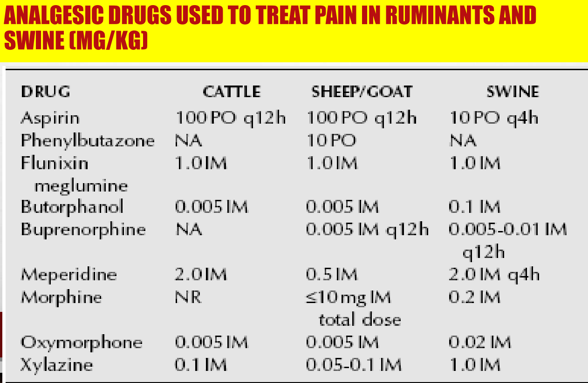
- Maintain hydration using IV fluids.
- Monitor and correct electrolyte abnormalities.
- Monitor for signs of vomiting during the period of recovery.
- Sutures to be removed (if any) within 10-14 days after the procedure to prevent the formation of a fistula
- IF PERITONITIS IS SUSPECTED TO HAVE OCCURRED – The option of an abdominocentesis is then required to confirm the presence of bacteria in the abdomen. If bacteria are presented past 8 hours after surgery, the anastomosis is leaking, and a second surgery is required.

Client Information
- Communicate with the client to LIMIT THE ANIMAL’S ACTIVITY and to keep the animal in an environment where their movement will be minimal. The client should be reminded of the importance of this measure to prevent reopening the wound.

- Ensure Proper upkeep of pens and pastures, the farmer should clear any protruding wires or fences, tools or any sharp surfaces that may reopen the wound or create new ones. This will play a role in the animals healing and reducing the occurrence of secondary infections.

- Important to maintain adequate nutrition and reduce stressors for proper healing of wound.

Costs

Prices for different procedures vary from practice to practice and country to country. A solid rule of thumb for a veterinarian in determining the price of a procedure and the many aspects that surround it is as follows.
Direct staff costs:
Veterinarian — x PRICE per hour (cost to practice)
Nurse — x PRICE per hour
Direct equipment costs:
Surgical pack (sutures, bandages, syringes, catheter)
Anaesthesia:
Direct equipment costs:
Surgical equipment per procedure (including instruments)
Share of practice overheads (per procedure)
Hospitalisation (1/2 day)
Total cost:

As a veterinarian, IT IS IMPORTANT TO NOTE:
- Clients demand fairness, transparency, and clarity of pricing and if they experience a lack of these, are more likely to seek them elsewhere.
- The practice's pricing strategy must not undersell the service or the products, but at the same time, must not open the practice up to accusations of profiteering or taking advantage.
- A rational pricing strategy must achieve four key aims: it must cover the practice's costs, provide an adequate return on the owner's investment, allow reinvestment for practice growth and be fair to clients.
- One of the most important determinants of setting fees is the client's perception of value.
- Receptionists, nurses and veterinarians should all be able to explain, on request, what the charges are for and why they are included, which requires regular staff training in understanding the practice's prices, the overall pricing strategy and structure.

