PROCEDURE FOR SUBCONJUNCTIVAL INJECTION
The animal is first anesthetized, to allow for proper administration
- The drug is first drawn up into the needle and syringe (PenStrep).
- The needle is then placed bevel up against the eye globe and is slowly pocketed into the conjunctiva (in the space between the sclera and conjunctiva).
- The drug is then slowly administered, forming a ‘bleb’ or a ‘bulge’ in the conjunctiva , and ensuring the needle remains under the conjunctiva.
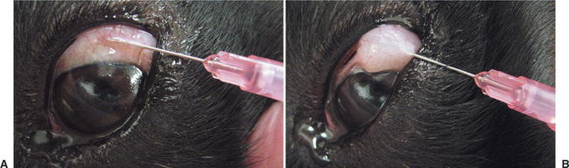
Image showing subconjunctival injection, and formation of bleb/bulge in conjunctiva.
(Picture taken from Ocular Pharmacology and Therapeutics | Veterian Key)

