PROCEDURE FOR EYELID TACKING
Firstly, the amount of eyelid (upper or lower, or both) “rolled” in is assessed and determined.
Anaesthesia is then administered.
1). Using a needle holder, suture and tissue forceps, the eyelid skin is isolated and held.
2) The first bite is taken as the suture needle is guided into the skin of the eyelid, close to the eyelid margin (usually starting at the corner of the eye)
3) The second bite is taken parallel to the first bite, entering on opposite side in which the first bite was taken (horizontal mattress pattern as seen below).
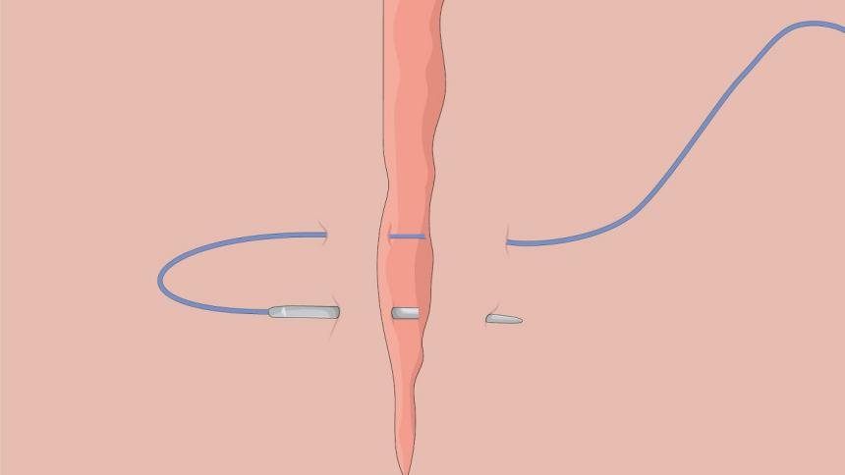
(even though horizontal mattress was done, vertical mattress can also be used)
- A surgeon’s knot is then performed. This tightens the mattress and allows the eyelid to roll out, temporarily correcting the entropion.
- Multiple horizontal mattress sutures are performed, completed with surgeon’s knot along the eyelid to allow the entire eyelid to roll out.

