Individual cow foot recording sheet
Date: Farm ID: Cow ID:
Lameness score:
Normal Mildly Moderately Lame Severely
Lame Lame Lame
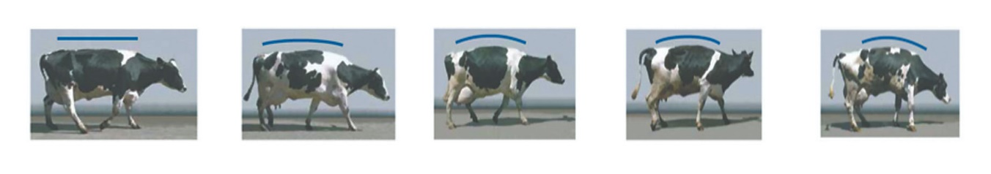

Please indicate below areas that are affected in the Hoof.
