**RELEVANT ANATOMY OF THE HOOF FOR DIGIT AMPUTATION**

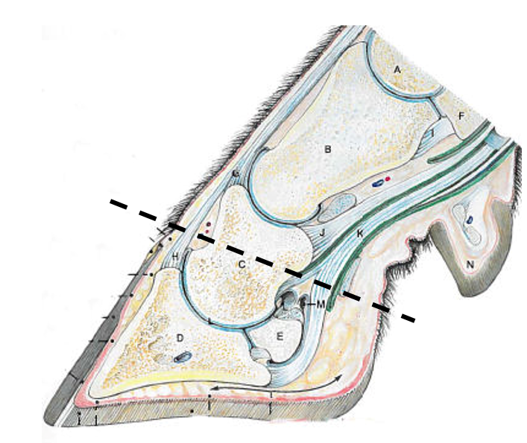

**Important structures:**

1. P1 bone (long pastern bone)
2. P2 bone (short pastern bone)
3. P3 bone (coffin bone)
4. Deep flexor tendon
5. Extensor tendon

**The dashed line indicates where the gigli wire should be placed and where it should cut through.**