THE BRANCHES OF THE LATERAL PALMAR ARTERY (BRANCH OF THE MEDIAN ARTERY) IN EQUINE FORELIMB.

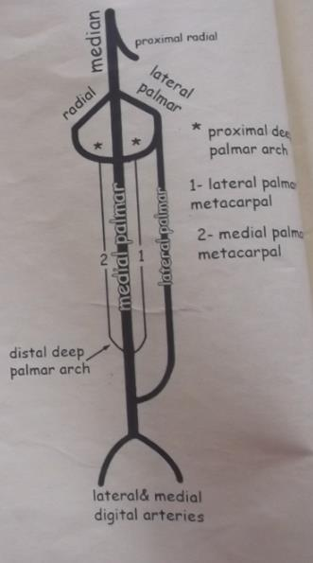

- The Lateral Palmar Artery joins the Collateral Ulnar Artery which forms the Supracarpal arch.
- A transverse branch from the Supracarpal Artery and a transverse branch from the Radial Artery joins and forms the Proximal Deep Palmar Arch.
- From the Proximal Deep Palmar Arch descends the Medial and Lateral Palmar Metacarpal Arteries.

- The Medial Palmar Artery is a direct continuation of the Median Artery and passes in the Carpal Canal (together with the Medial Palmar Nerve, Superficial deep flexor tendon and the deep digital flexor tendon) and descends into the Metacarpus and Proximal fetlock joint.
- The Medial Palmar Artery divides into the Medial and Lateral digital arteries.
- Each digital artery (medial and lateral) gives off:
-Artery of P1
-Artery of P2
-Dorsal branch to P3
-Branch to digital cushion
- The medial and lateral digital arteries, then finally form the Terminal Arch inside the Solar Canal.

