**Anatomy of the Hindlimb (Bones)**

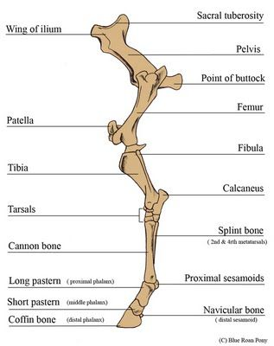

Tarsal Bones

