Equipment & Materials
- 20 Gauge Needles
- 1ml, 5ml & 10ml Syringes
- 2% Xylazine
- 5% Flunixin
- Penstrip LA
- 10% Tolazoline
- 2% Lidocaine
- size 20 scalpel blade
- Barnes dehorner
- Dehorning Iron
- Alcohol Swabs
- Cotton
- Bactrovet silver AM Spray
- Matabicheras fort dodge Spray
- Halter and rope

Images Illustrating Equipment
20 Gauge Needles Gauges Size 20 scalpel blade
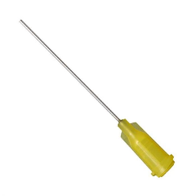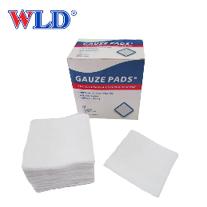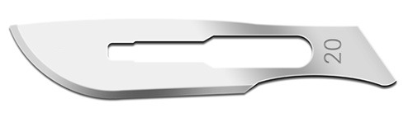
1ml, 5ml 10ml Syringes
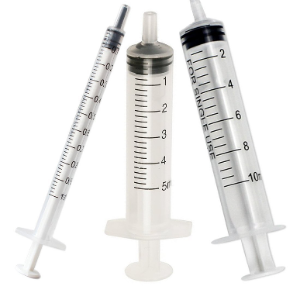
2% Xylazine 10% Tolazoline 2% Lidocaine
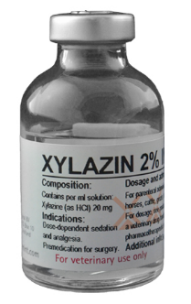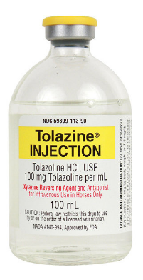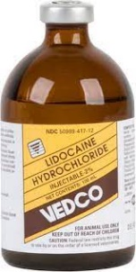

5% Flunixin Penstrip-40
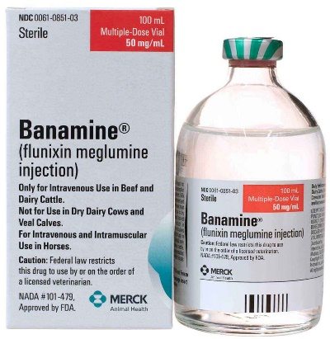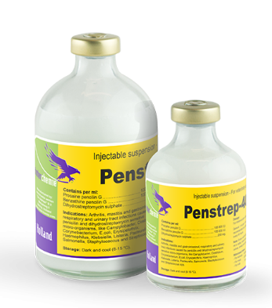
Barnes dehorner Dehorning Iron
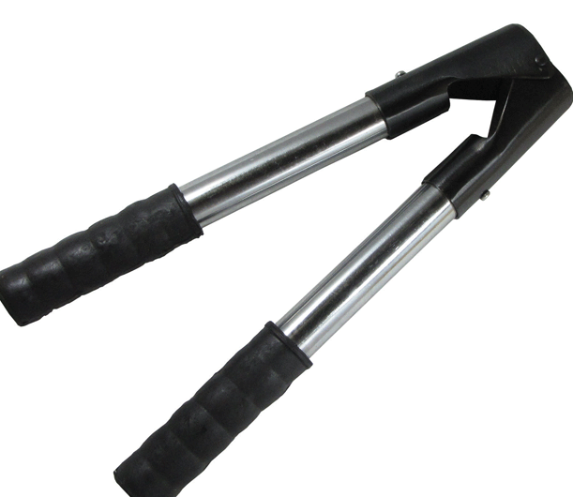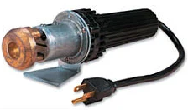

Alcohol Swabs Bactrovet silver AM Spray
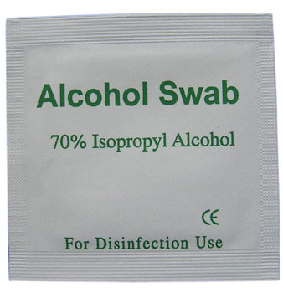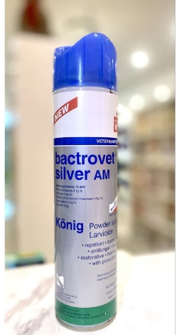

Matabicheras fort dodge Spray Halter and Rope
