Equipment and Instruments

- Restraint
- Halter and Lead rope




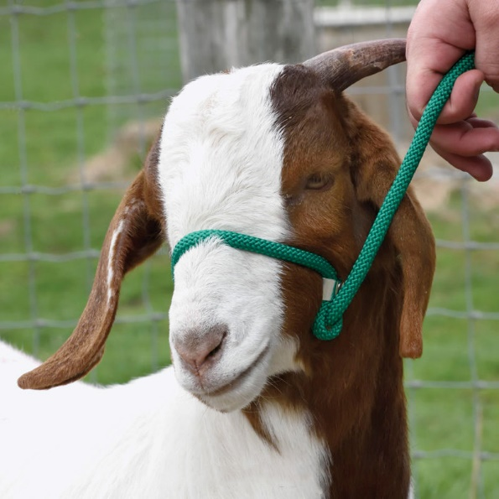

- Chute
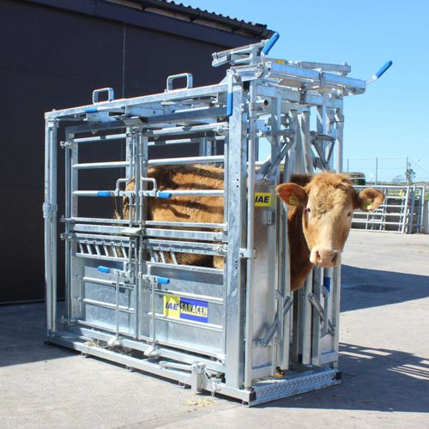

- Stanchion


- Nose tong


- Physical Examination
- Thermometer
- Stethoscope
- Penlight
- Strip cup test materials (strip cup)
- California mastitis test materials (paddle, reagent, iodine solution)
- Sample cups for urine, milk and faeces (if necessary)
- Test tubes for blood collection and needle and syringes (if necessary)

- Nerve Blocks
- Needles and syringes
- Alcohol swabs

- Special Instruments
- Doyen (Pean) Intestinal forceps
- An atraumatic instrument used in intestinal surgical procedures to grasp intestines and temporarily occlude lumen.
- Designed with characteristic long, boned jaws and short shanks and have fine longitudinal serrations along the length of the gripping surface.
)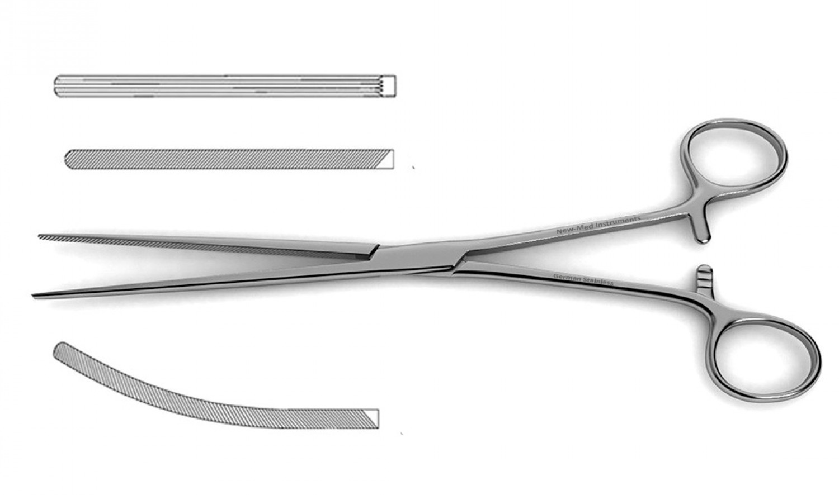
- Rectal Rings:
- Used for rectal prolapse repairs in calves, pigs, sheep and goats.
- Used where tube is inserted into rectum in order to tie off prolapse next to body with either elastrator ring or umbilical tape being used to secure. Prolapsed section should slough off in approximately 4-7 days.
- Comes in varying sizes to accommodate for different sizes of animals but the largest size as possible should be used.

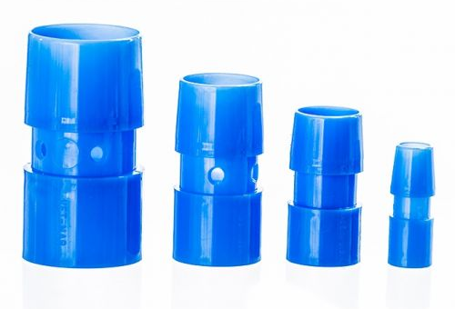

- Elastrator ring:
-Used for rectal ring securing.
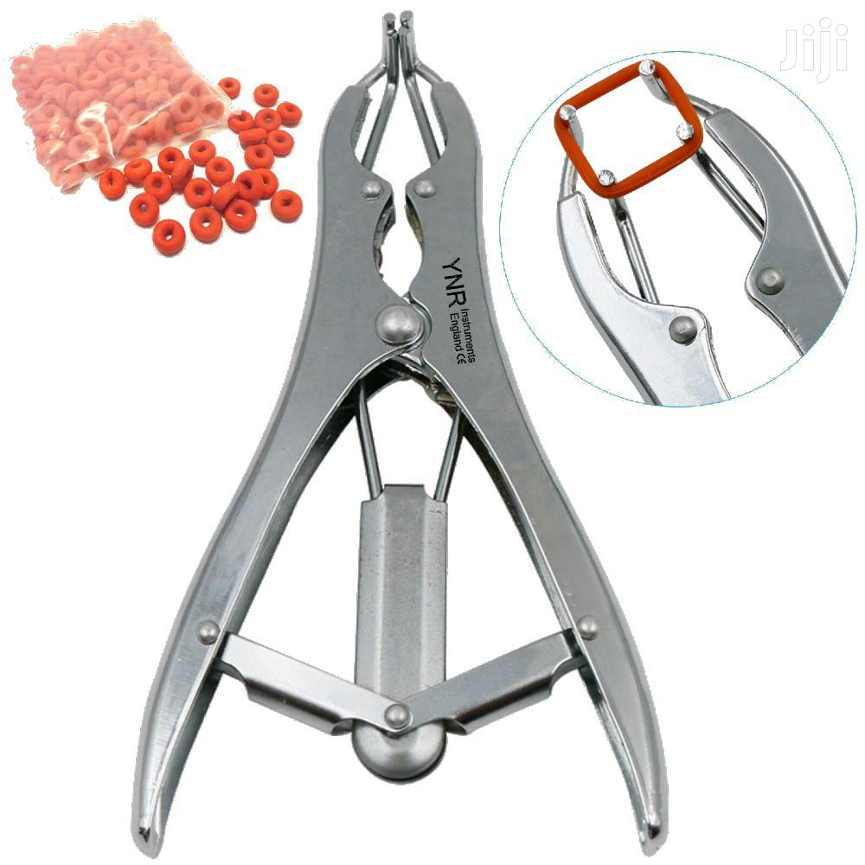

- Umbilical tape:
-Used for rectal ring securing.

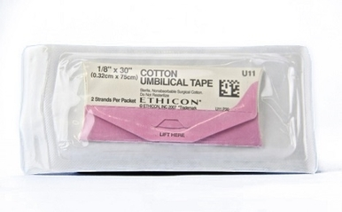



- Drugs
- Xylazine
- 2 % Lidocaine
- Flunixin meglumine
- Penicillin
- Atropine
- Epinephrine
- Tolalozine

- Surgical Instruments and Material
- Needle holder
- Haemostats (straight, curved, mosquito, crile, Kelly)
- Plain tissue forceps (atraumatic compared to traumatic rat tooth forceps which can damage intestine).
- Suture material:
- 3-0 Absorbable and synthetic suture material (used for mesentery of the small intestine)
- 3-0 or 4-0 monofilament absorbable suture (minimizes trauma, reduces capillarity and bacterial colonization)
- Metzenbaum scissors- small (to trim necrotic or excessive tissue)
- Scalpel handle and blades

- Other
- Gauze
- Gloves

