Equipment Table – Intestinal Surgery

Scalpel Blade + Handle  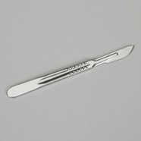 | - No. 3 + No. 4 Handle  - 20 – 23 size blades (for handle 4)
Doyen Clamps  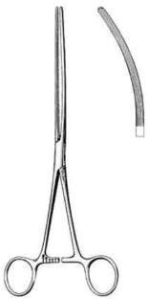 | - Atraumatic  - Used to clamp intestinal tissue

Mayo Hegar Needle Holder  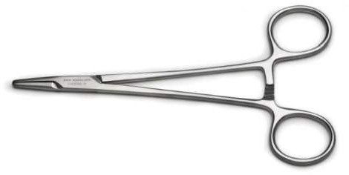 | - Holds needle used for sutures
Metzenbaum Scissors  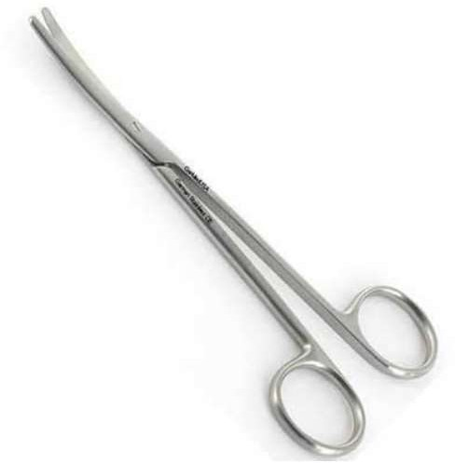 | - Used for cutting the delicate intestinal tissues and structures.

Debakey Tissue Forceps  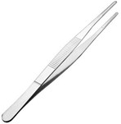 | - Atraumatic forcep

Surgical drapes  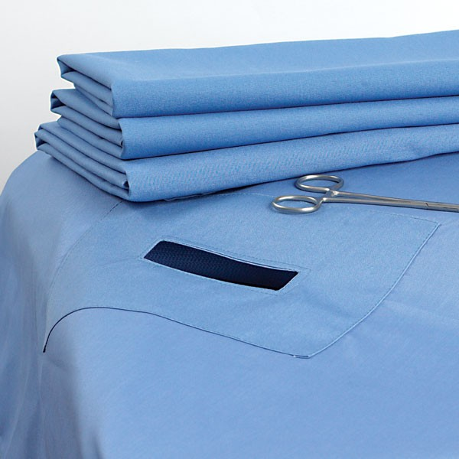 | - Keeps surgical site/area sterile.

Profix Rectal Rings  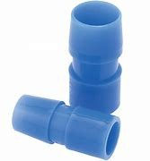 | - Profix Rectal Rings are used to repair rectal prolapses in calves, sheep, goats and pigs.  - To use, insert the tube into the rectum and tie off the prolapse next to the body using an elastrator or castration band or umbilical tape.  - The prolapsed section should slough off in four to five days.
Towel Clamps  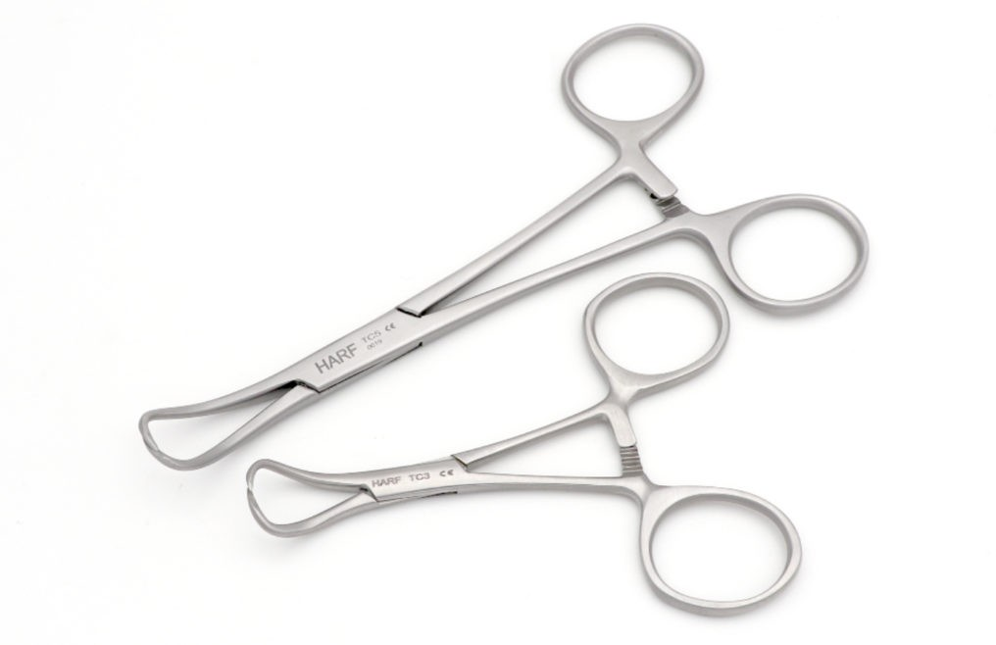 | - Used to secure drapes to ensure they do not move during surgical procedures
Elastrator tool + bands  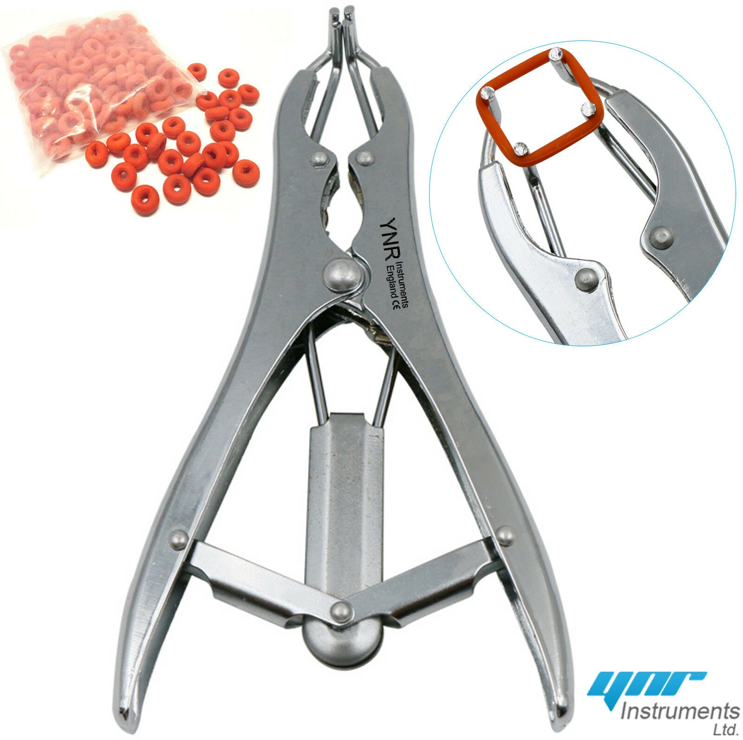 | - Used in rectal prolapse procedures  - Placed around the rectal rings to assist in amputation of the required intestinal tissue to slated to be amputated.
Laparotomy Sponges  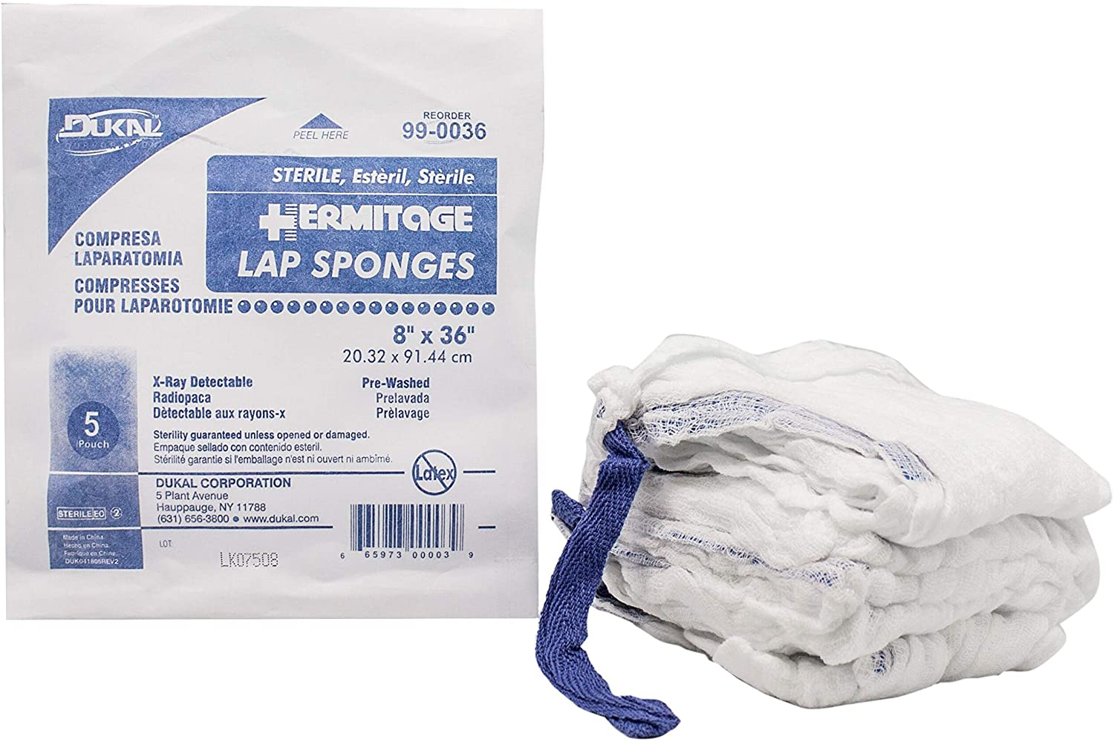 | - Used for abdominal and thoracic surgery or in deep wounds to absorb fluids but can also be used to wall off surgical site.

