Equipment and Instruments

- Restraint
- Halter and Lead rope
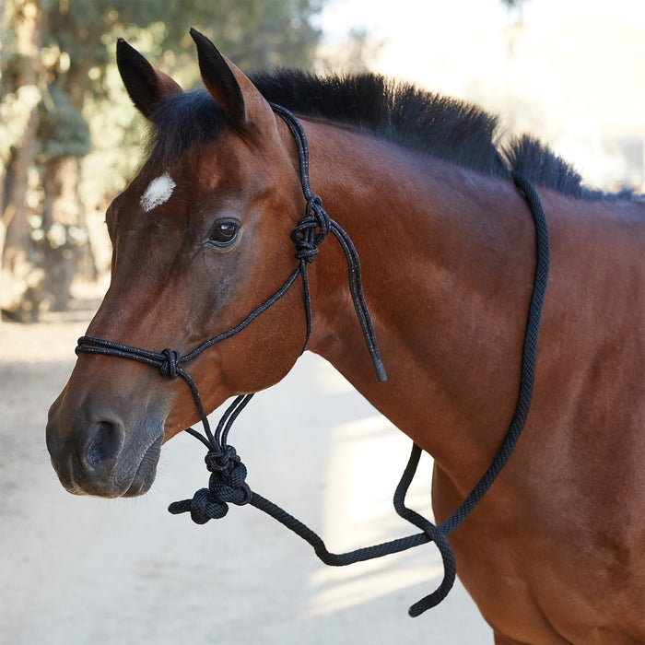

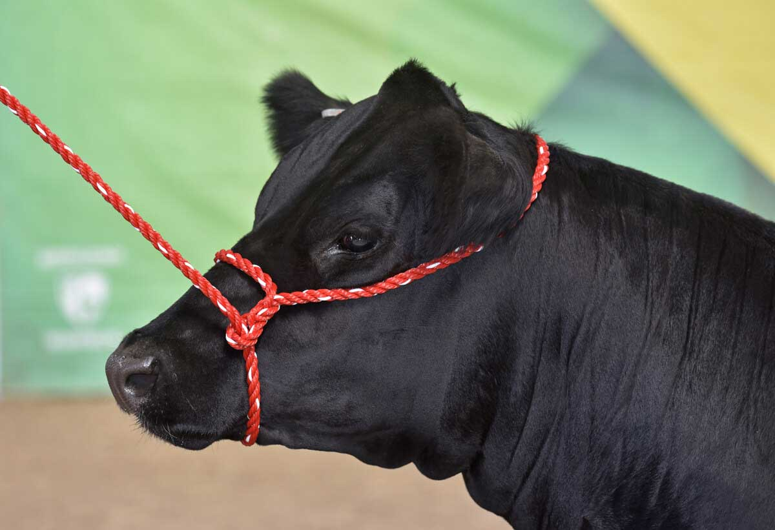

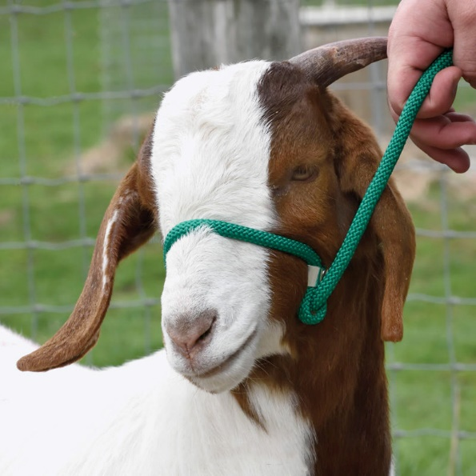

- Chute
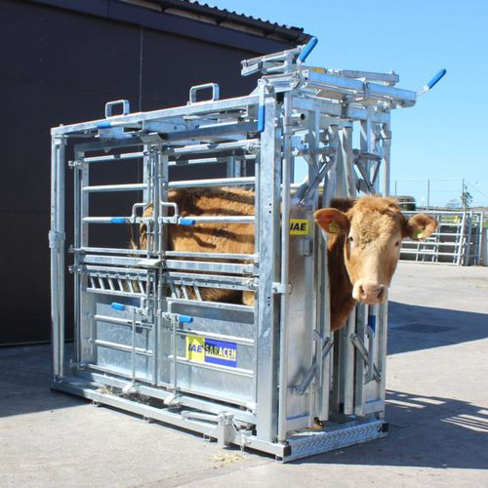

- Stanchion
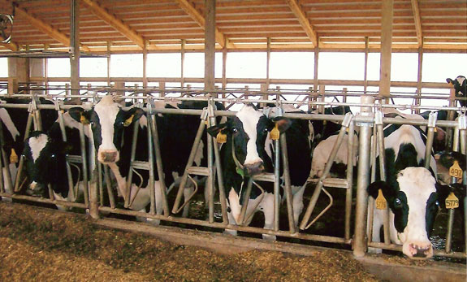

- Nose tong
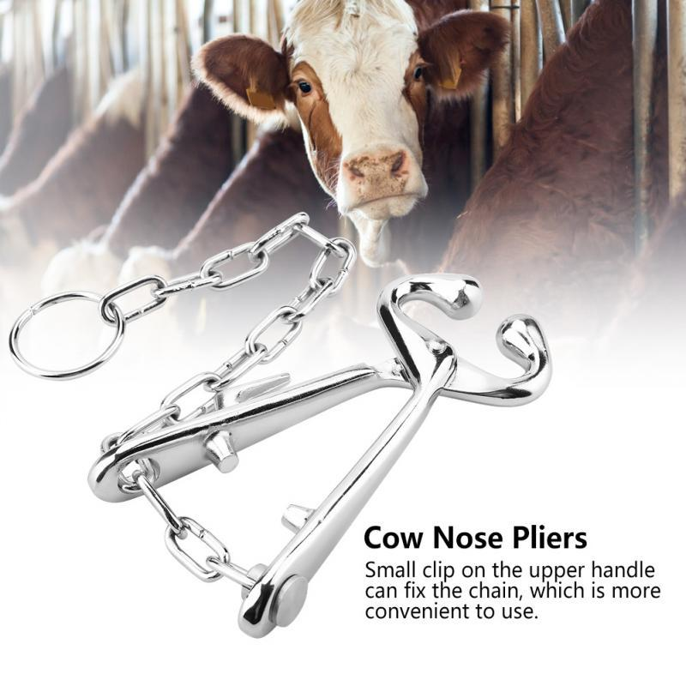

- Physical Examination
- Thermometer
- Stethoscope
- Penlight
- Strip cup test materials (strip cup)
- California mastitis test materials (paddle, reagent, iodine solution

- Nerve Blocks
- Needles and syringes

- Special Instruments:
- Danish teat splitter
- Used for opening teat orifices (that of which are small)
- Used where screw end is turned to release blades which cut in 2 directions. The blades then move back in.
- Has various types. E.g. Wisconsin teat splitter

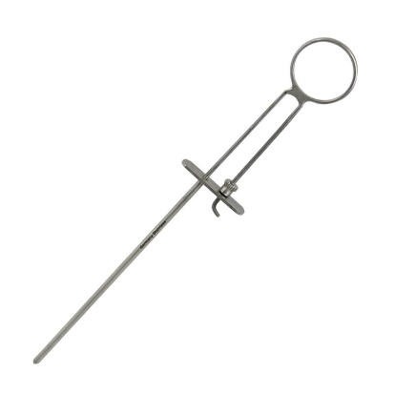

- Hog's tumour extractor
- Used where unit slides back and forth to separate the cutting edges
- Advantage: tissue remained undamaged on entry with tool and tumour can be excised without damaging teat canal.

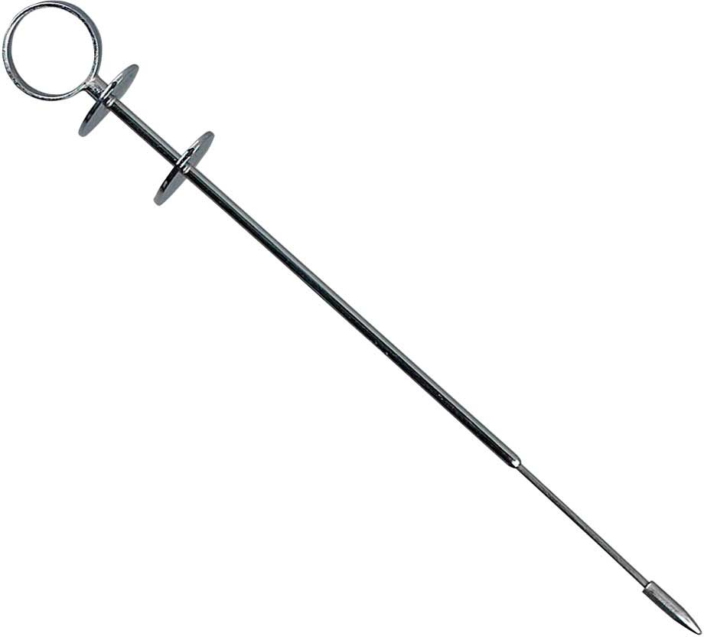

- Teat tumour extractor with 3 rings
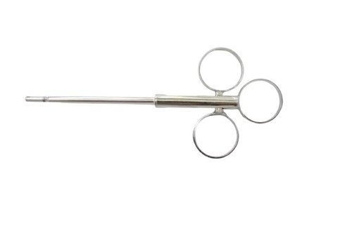

- Alligator forceps
- Used for removing lactoliths from cow’s teats
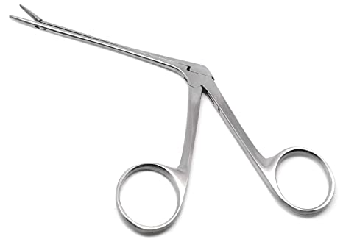

- Spiral teat curette
- Used to enlarge the teat canal
- Used if lichty teat knife is not productive
- Used by twisting like a screw into teat canal then pull out quickly.

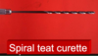

- Teat cutting knives

- Cornell teat curette
- Used to cute on the round inner surface.

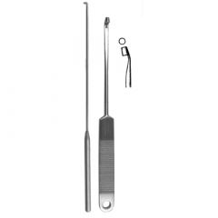

- Yankee teat bistoury
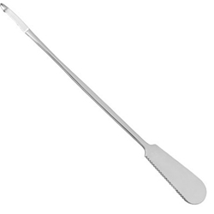

- Udall teat bistoury

- Lichty teat knife
- Used for tight teat/streak canal to increase diameter and subsequent milk flow.
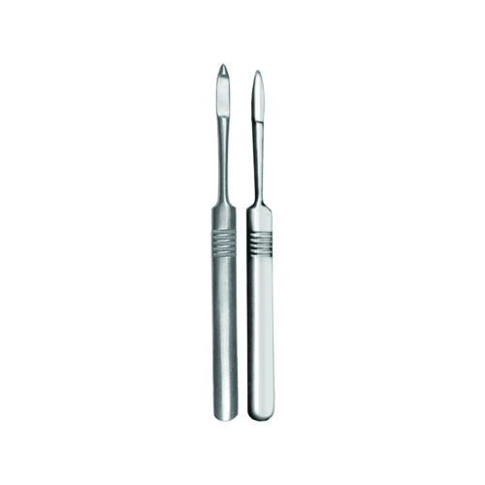

- Teat cannula
- Used to drain milk from the gland.
- Advantage/Other use: can be self-retaining with a bulb where it can be left in the teat while still allowing milk to pass. Leaving the cannula in while the teat heals allows the spincter to heal larger resulting in more milk.
- Has different sizes to accommodate for the different sizes of animals.

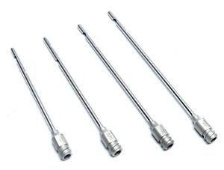

- Teat widener or expander
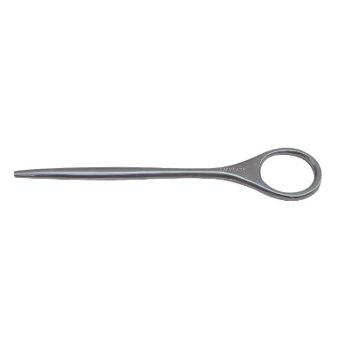

- Dr Larsons self retaining teat tube
- Used to keep milk from draining from teats until you are ready to milk
- Advantage: helps prevent postoperative stenosis.
- Disadvantage: predisposed animal to easy infection.

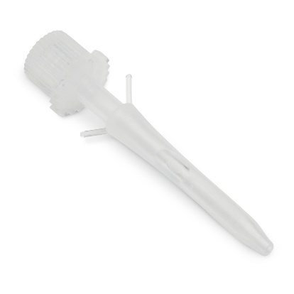

- Doyen intestinal clamp
- Used to occlude tissue atraumatically where the instrument does not crush. Control haemorrhage while debridement and suturing is performed.

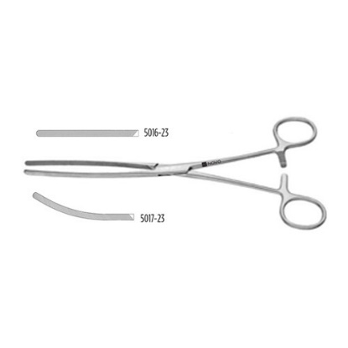

- Drugs
- Xylazine
- 2 % Lidocaine
- 1% proparacaine ophthalmic solution
- Flunixin meglumine
- Penicillin
- Atropine
- Epinephrine
- Tolalozine

- Other
- Hair clipper
- Number 3 scalpel handle (for debridement)
- Number 10 surgical blade (for debridement)
- Adson-brown tissue forceps (manipulation of tissue and for removal of foreign bodies)
- Metzenbaum scissors- small (to trim necrotic or excessive tissue)
- Suture material:
- Absorbable 3.0 o4 4.0 on atraumatic needle for mucosal and subcutaneous suturing and is needed so that as small holes will be made as possible to preserve milk flow and allow for proper healing).
- Non-absorbable monofilament suture material of size 2.0 for skin suture.

- Gauze
- Gloves

