Anatomical Review of the Teat and Udder

Anatomy of the Udder In bovines,
The udder is a structural unit comprising four quarters: two fore and rear quarters. Each quarter corresponds to a functional mammary gland and bears one principal teat.

A prominent median intermammary groove generally marks the division of the udder into right and left halves. A transverse groove separates the fore and hind quarters of each half externally. The udder is suspended by strong fascial sheets that surround and encloses the gland substance and extend inward to fuse with the connective tissue framework that permeates the entire region.

The internal structure of the udder consists of gland parenchyma and connective tissue intermingled in each other. Each gland develops around a branching duct system. The functional unit of the glandular tissue is the alveoli.

Alveoli are microscopic, spherical structures lined by a single layer of cuboidal to columnar epithelial cells and smooth cells. A cluster of alveoli encapsulated by connective tissue sheets with their ducts constitutes a lobule. A Group of lobules surrounded by a septum of connective tissue forms a lobe.

The terminal ducts unite further to form intra – lobular ducts. These ducts unite successively to form large interlobular ducts, intra-lobar and interlobar ducts. The interlobular ducts open into a large basin called lactiferous sinus which empties into a large cavity called gland cistern which further continues as teat cistern. The wall of the teat cistern is continuous with the exterior through a narrow tube known as streak canal which is the main barrier against infection.

At the junction of the teat cistern and streak canal, the mucosa of the teat canal is arranged in a group of radial folds called the “Rosette of Furstenberg”. At the end of the teat, the streak canal is surrounded by sphincter composed of smooth muscle fibres. The blood supply to the udder is by the external pudendal artery. Two posterior mammary lymph nodes located on the caudal aspect of the mammary gland receive the afferents from the posterior part of the gland. Udder receives multiple innervations from lumbar and sacral spinal nerves
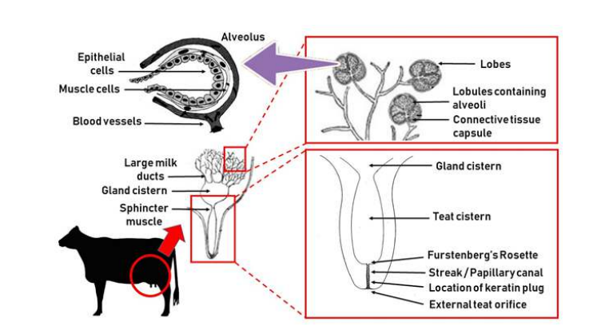

The udder also contains a lymphatic system. It carries waste products away from the udder. The lymph nodes serve as a filter that destroy foreign substances but also provide a source of lymphocytes to fight infections. Sometimes, around parturition first lactation animals suffer from oedema, partly caused by the presence of milk in the udder which compresses the lymphatics
