**CLASSIFICATION OF TEAT LACERATION**

**Is based upon:**

1. **Duration from the time of trauma**

Teat lacerations are categorized as acute or chronic (> 2 hours old). Surgical intervention on the teat is best performed during the first 12 hours after the injury. Later, swelling of the teat can be too severe to permit adequate reconstruction of the tissue. These injuries benefit from medical therapy (hydrotherapy and a nonsteroidal anti-inflammatory drug) (NSAID) before attempting primary closure of the defect (delayed first intention healing). However, with complex lacerations (inverted ‘‘Y’’ or ‘‘U’’), it is recommended to try primary closure even if the laceration is older than 12 hours. The repair may partially dehisce, but the portion that heals will facilitate the surgical revision performed later in the healing process

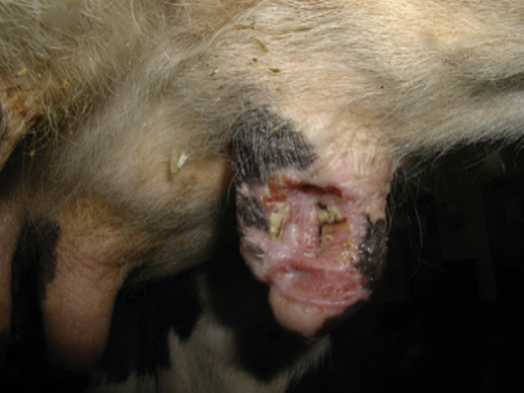

**Picture 1: Showing teat laceration healed by second intention ready to be revised and closed surgically to achieve first-intention healing.**

1. **Localization and conformation**

Teat lacerations are classified as simple or complex (inverted ‘‘Y’’ or ‘‘U’’) longitudinal or transverse, and proximal or distal. The orientation of the blood supply of the teat is longitudinal. A transverse laceration results in more damage to the blood supply resulting in more edema, avascular necrosis, and dehiscence postoperatively compared with a longitudinal laceration. The more circumference is involved, the worse is the prognosis. Distal injuries involving the streak canal are also regarded as having a poor prognosis. Reconstruction of the streak canal is difficult and can cause partial or complete milk flow obstruction. Injury to the distal end of the teat compromises the defense mechanisms of the quarter against mastitis making the animal at higher risk for clinical or subclinical mastitis. Distal injuries may lead to avascular necrosis of the distal end of the teat.



**Picture 2: Showing complex laceration.**

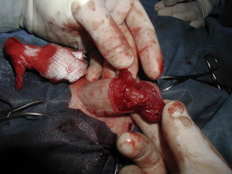

**Picture 3: Showing transverse laceration**

1. **Thickness**

Teat lacerations are classified as being partial thickness (skin to submucosa) or full thickness (skin to mucosa with milk leaking out of the incision). With full-thickness lesions, the defense mechanisms of the teat against mastitis are bypassed, increasing the risk of clinical mastitis. Prompt surgical reconstruction of the injured tissue is needed to protect the quarter against environmental pathogens. In cases of incomplete lacerations (when the integrity of the teat cistern has not been compromised), surgical intervention may not be necessary. Therefore, secondary healing by medical management of the wound may be sufficient. However, contraction of the tissue during healing can change the alignment of the teat creating problems during machine milking. With show cows, reconstructive surgery of the teat is necessary to obtain a satisfactory cosmetic outcome.

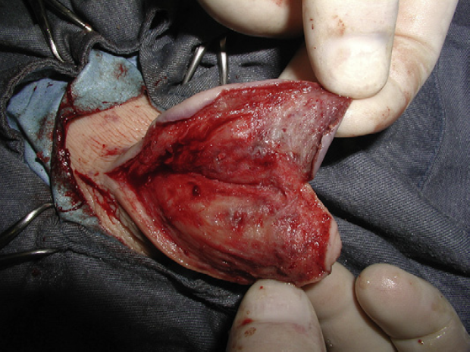

**Picture 5: Shoeing partial-thickness laceration. (The teat cistern has not been invaded.)**



**Picture 6: Showing full-thickness laceration. (The teat probe has been entered through the streak canal).**