Rhinehart Dehorner
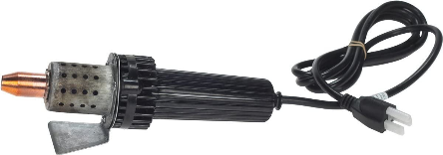
Rhinehart dehorner is an electric dehorner used in ruminants.
- Efficient once the base of the horn is not larger than the inside of the dehorner ring

- Very little blood loss as it also cauterizes the area

How it’s used.
- Properly restrain animal, as the dehorner is extremely hot and can cause serious damage to the handler and persons restraining the animal
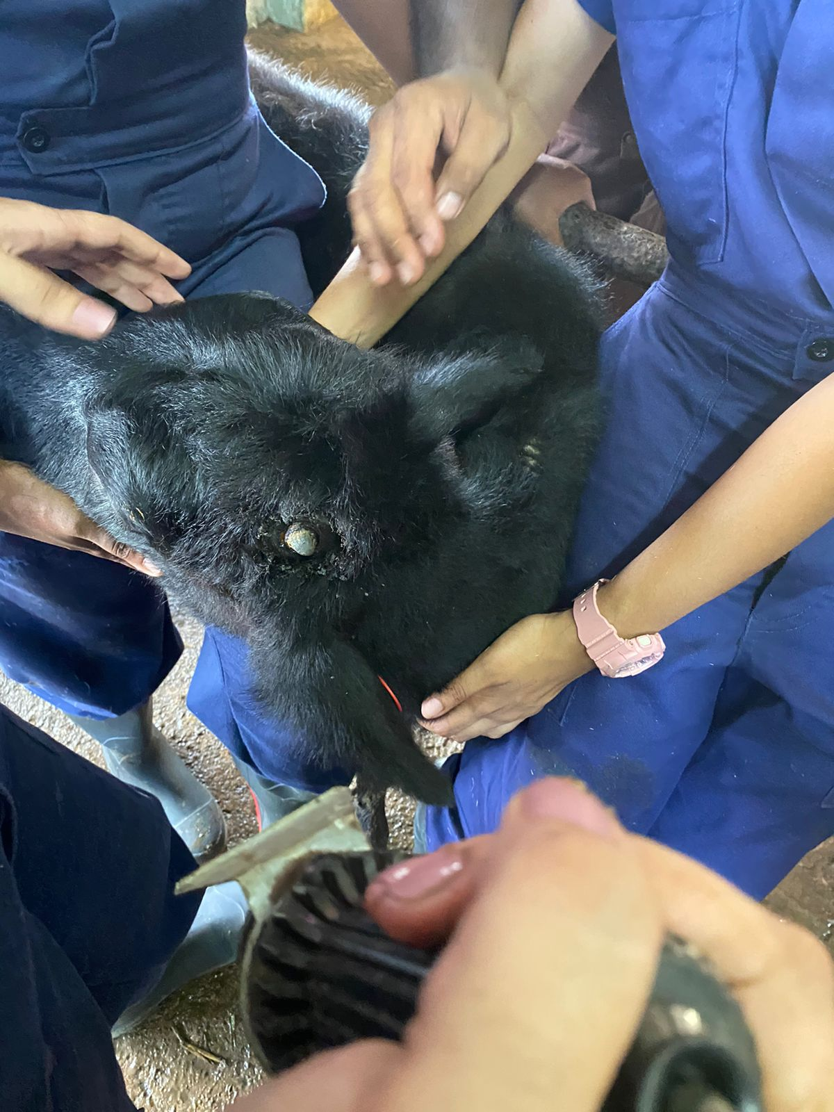

Fig.1 – Animal is restrained during disbudding process

- Place dehorner over horn bud.
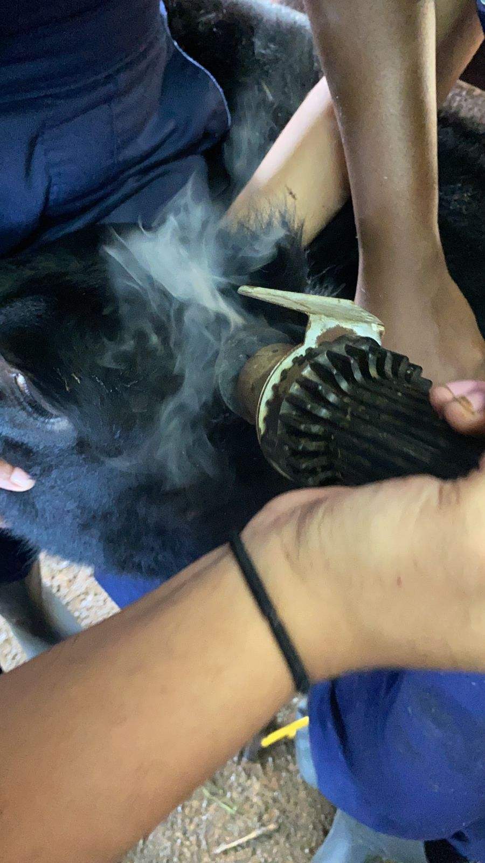
Fig. 2 – Dehorner is placed firmly over the horn bud. Care the ear is also held out of the way to prevent burning
- Rotate the dehorner slowly while pressing on the bud for 10 seconds

- Remove and observe for a copper colour on the bud. If the copper colour is not seen, repeat as needed.
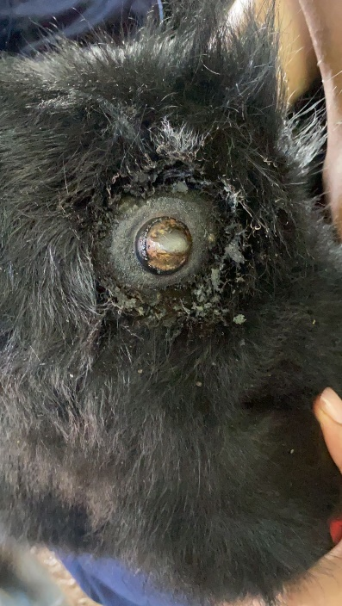 Fig. 3 – Copper colour seen on bud
Do not leave dehorner on the skull longer than 10 seconds as this can cause damage to the skull.

