EQUIPMENT

Enterotomy

Instrument | Use
General surgery pack
Moist lapatoromy sponges | Reduce risk of contamination  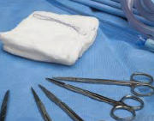
Metzenbaum scissors | used to cut delicate tissue and blunt dissection  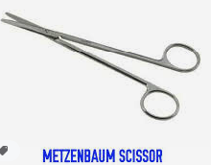
Balfaur retractor | used as a self retaining abdominal retractor to clearly expose the surgical site during surgery.  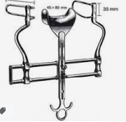
Doyens (pean) atraumatic bowel clamps | To occlude the lumen of the intestine orad and aborad to the lesion to reduce the risk of leakage of intestinal contents  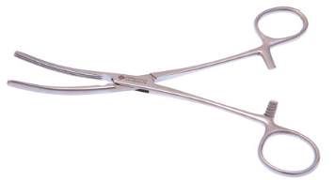
Number 11 blade | To incise bowel on anti-mesenteric boarder
Debakey forceps | to minimize hold the edges of tissue are handled during enterotomy suturing for closure  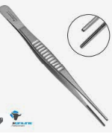
4/0 USP polydioxanone and needle holder | to close the small intestine  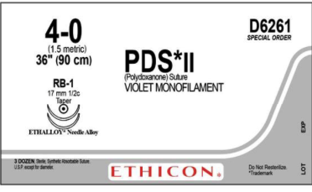
10ml syringe with sterile saline and 24 gauze needle | used to check for any visible signs of leakage
Allis tissue forceps | to retrieve the foreign material  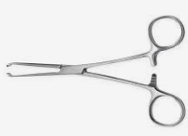

Enterectomy- resection and anastomoses

Instrument | Use
Moist sponges | Reduce risk of contamination
Metzenbaum scissors | used to cut delicate tissue and blunt dissection
4/0USP monofilament suture material/ absorbable no. 00 suture material | used to ligate the individual arcade vessels supplying the affected segment of bowel to be removed. Also used to close the mesentery  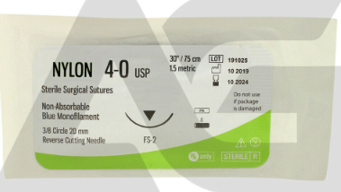
doyen clamps | placed on either side of the site of resection
Hemostats clamps | used to securely hold tissue and compress blood vessels.  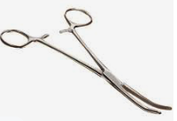
number 11 blade | used to cut tissue between clamps
thoracic abdominal stapler (TA30) | used to close stumps of the bowel eg. Ileum, large colon.  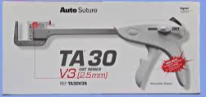
cautery | to double ligate the mesenteric vessels.  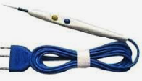
stent bandage, belly bandage | wound protection post surgery.  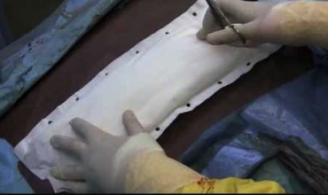

Rectal prolapse

Rectal ring (cannula) | The cannula and suture (circumferencial ligature)will stimulate sloughing of the distal portion of the prolapse
Standard surgical kit  -curved mayo scissors  -forceps  -surgical blade | to properly cut and handle tissues.
-18 gauge needles spinal 3-6 inches in length | To stabilize the prolapse
Curved hemostats | to ligate blood vessels and carry out hemostasis
Number 0 absorbable suture material (example: catgut thread chromic). | used to place the sutured rectum back into its normal position by simple replacement  