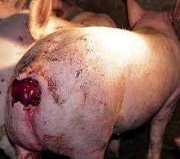

Signalment
Age: 4years
Sex: male
Breed: Landrace
Weight: 200kg
History:
A 200kg landrace boar presented with a rectal prolapse having 6cm necrotic ring. The boar was seen with this condition by the farmer 8 days prior. Previous treatment included regular cleaning and attempted physical re entry with no success. The animal had a body condition score of 2.5, was lethargic and dehydrated.
Restraint
Boar should be restrained using a hog snare.
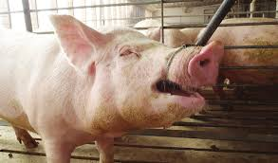

Epidural anesthesia is performed which will have a lasting effect for up to 2 hours.
Pre anesthetic can be used to aid in restrain with use of xylazine and ketamine IM at 1mg/kg and 10mg/kg respectively. Wait 10minutes for effect to take place.
Needle injection site is shaved off any hair and cleaned. Sterile gloves are then worn to perform epidural injection.
For a large boar of 200kg, a 5-7inch needle of 16-18 gauge is used. To prevent any bending of needle, a shorter 1-2inch 14-gauge needle is first inserted as a protective sleeve and then the 18-gauge needle is passed through.
To locate the point of injection, an imaginary transverse line joining the ilia crests indicates the lumbosacral articulation. A vertical line that then runs from the fold of the flank to tuber coxae and then over the back to mirror a vertical line on the other side pinpoints the injection site.

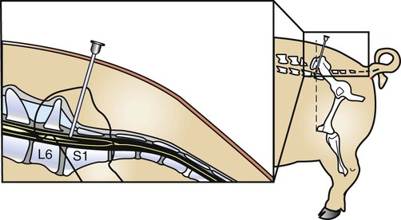

The needle is inserted 2-5cm caudal to the transverse line. It is directed ventrally and slightly cranial. Insert needle to penetrate osseous foramen and ligamentum flavum are penetrated as indicated by jerking action of pig. After injection, the tail relaxes within 2 minutes.
2% lidocaine is injected at 6ml for an 80-100lb pig and a maximum of 20ml for adult pig. Being a 200kg boar, 12ml of lidocaine is injected. Solution can be locally infiltrated into skin prior to spinal insertion to desensitize area.
Wait 10 minutes for anesthesia to take effect with 20 minutes for full effect lasting for up to 2 hours.
With animal sedated begin cleaning the prolapse and surrounding skin to remove any debris or dirt.
Resources:
https://veteriankey.com/surgery-of-the-swine-reproductive-system-and-urinary-tract/
https://veteriankey.com/porcine-surgical-procedures/
Turner and McIlwraith’s Techniques in Large Animal Surgery
Noordsy’s Food Animal Surgery
Farm Animal Surgery

