POST OPERATIVE CARE- CASE 1

Management protocols:
The affected teat/s should be checked daily to determine if there is proper let down of milk over a 2-week period.
A Larson’s teat tube can be used to allow drainage of a specific quarter, allowing the other quarters to be milked, this would allow for at least some milk collection.
There should be proper use of antibiotics as well as a dry off period to allow excretion of the drug. (drug withdrawal period)
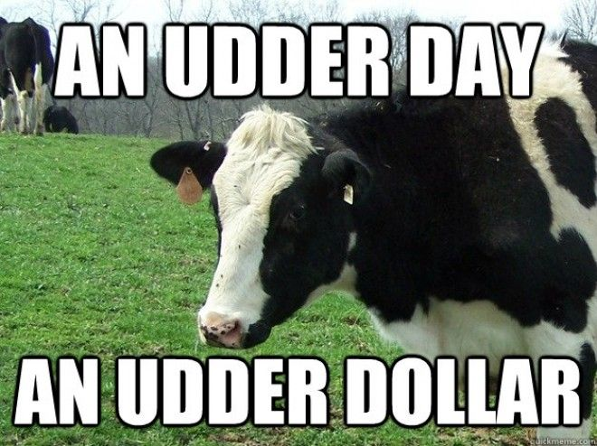

Farmer/Client Communications:
The vet should inform the farmer to regularly check up on the cow for any signs of mastitis/infection. The sutures should be removed in a timely manner to prevent infection. The teat/s which is/are infected should be drained to remove any excessive pressure on the suture line. If milk is collected from the teat it should not be sold or used for calves as there may still be pathogenic bacteria. Sutures would be removed in 2-weeks’ time, after aseptic preparation of the surgical site.

POST- Operative drugs:
Antibiotics- Pen-strep – its withdrawal period (3 days for milk)
Dosage- 4ml/100kg – IM
Should be given once daily for 3-5 consecutive days

Intramammary treatment- Gentamicin 150mg, once a day for 3 days
Withdrawal period of 4 days

Flunixin Meglumine- 2.2mg/kg- IV, once a day- for 3 days
2 days in milk – withdrawal period
Should not be used in dry dairy cows

