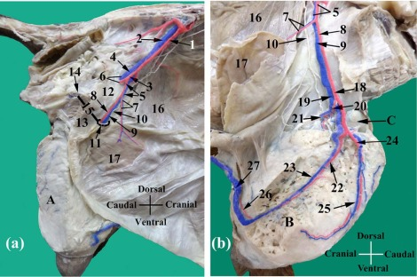

A photograph of dissected abdominal and pelvic cavities (a) and inguinal region (b) of the goat showing the origin and course of the external pudendal vessels; 1- External iliac artery, 2- External iliac vein, 3- Deep femoral artery, 4- Deep femoral vein, 5- Pudendoepigastric trunk, 6- Medial circumflex femoral vessels, 7- Caudal deep epigastric vessels, 8- External pudendal artery, 9- External pudendal vein, 10- genitofemoral nerve, 11- Deep inguinal ring, 12- Inguinal ligament, 13- Pre-pubic tendon, 14- Pubis, 15- Distance between 11 and 14, 16- Internal abdominal oblique muscle, 17a-Rectus abdominis muscle  (after reflection of the inner rectal sheath), 17b- Reflected rectus abdominis muscle and its outer rectal sheath, 18- Mammary artery, 19- Mammary vein, 20- Caudal basal artery, 21- Caudal basal vein, 22- Cranial mammary artery, 23- Cranial mammary vein, 24- Middle mammary artery, 25- Middle mammary vein, 26- Cranial superficial epigastric artery, 27- Cranial superficial epigastric vein.

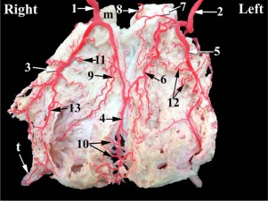

A photograph of dissected dorsal aspect of goat's udder showing the distribution of the mammary artery; m- Mammary lymph node, t- Teat, 1- R. mammary artery, 2- L. mammary artery, 3- R. cranial mammary artery, 4- R. middle mammary artery, 5- L. cranial mammary artery, 6- L. middle mammary artery, 7- Ventral labial branch, 8- Dorsal labial and mammary branch of the ventral perineal artery, 9- R. medial sinus branch, 10- Parenchymal branches of the R. middle mammary artery, 11- Parenchymal branches of the R. cranial mammary artery, 12- Dorsal branches of the L. cranial mammary artery, 13- Lateral sinus branch of the R. cranial mammary artery.

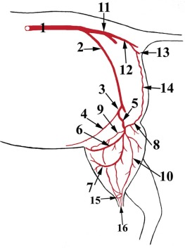

A diagram showing the arterial supply of goat's udder; 1- Abdominal aorta, 2- External iliac artery, 3- Pudendoepigastric trunk, 4- Caudal deep epigastric artery, 5- External pudendal (mammary), 6- Cranial mammary artery, 7- Middle mammary artery, 8- Ventral perineal artery, 9- Caudal basal artery, 10- Caudal mammary artery, 11- Internal iliac artery, 12- Internal pudendal artery, 13- Ventral perineal artery, 14- Dorsal labial and mammary branch of 13, 14- papillary Arterial circle, 16- Papillary arteries.