Preoperative procedure for scenario 1
Signalment of Cow
Sex: female dairy cow
Breed: Holstein
Age: 4 years
Weight: 450 Kg
Signalment of goat
Sex: female
Breed: Saanen
Age: 3 years
Weight: 70 kg
On examination of both animals, they were healthy and showed no signs of disease. However, their hoofs were overgrown and in need of a trim to prevent future problems.

Restraint for cow
If livestock crush is available, lead animal into crush and raise legs one at a time to allow access for trimming. Ensure hoof is stable to allow for accurate and safe trimming.
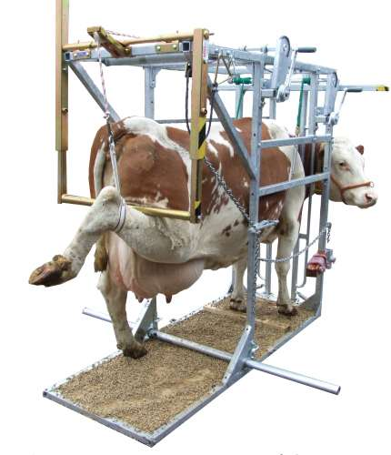
If not crush is available then use of rope to lift the leg with use of a bar and stanchion
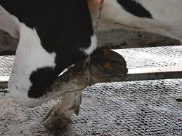

Restraint of goat
Tie halter onto goat to prevent escape.
Goat can be cast into lateral recumbency or on rump to allow access to hoofs.
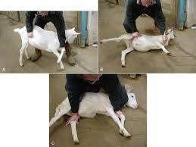

Once animals are restrained then hoofs can be cleaned with water or brush to remove debris or mud and make hoof visible for trimming.

