Intraoperative
https://www.youtube.com/watch?v=Bv5Fv_1UwcE&ab_channel=NZRacingNews
https://www.youtube.com/watch?v=qNrAPMBxLSE&has_verified=1&ab_channel=1GoldHorse
- Grasp lower testis with thumb and forefingers
- Make incision along length of testis through tunica dartos and scrotal fascia leaving the tunica vaginalis parietalis intact.
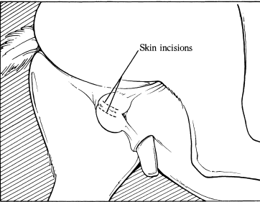
- Pressure is applied with thumb and forefingers to extrude testis from within common tunic (tunica vaginalis parietalis).
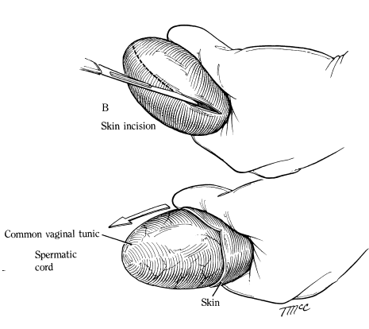
- Grasp testis with hand and strip subcutaneous tissue from common vaginal tunic as far proximal as possible. Gauze sponge may be used to assist in stripping subcutaneous tissue.
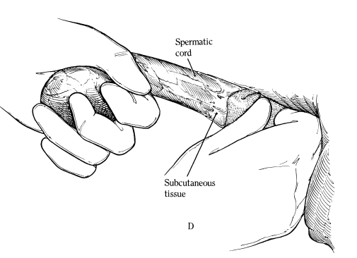
- At cranial pole of testis, incise the common tunic. Maintain tension by hooking finger within the tunic and continue with proximal incision to release testis from within common tunic.
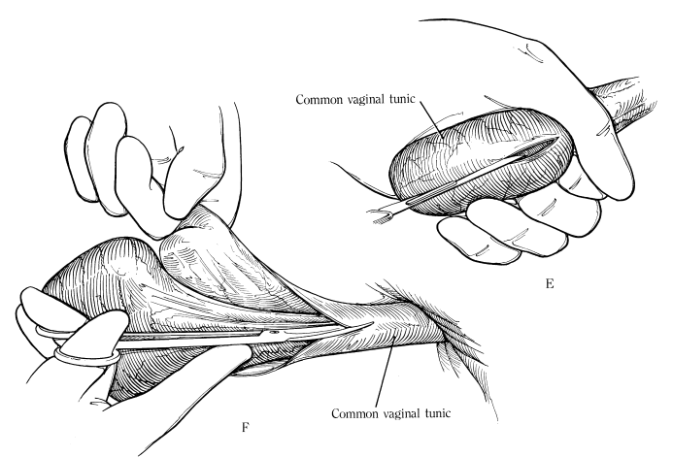
- Using fingers, separate the spermatic chord from ductus deferens, common tunic and external cremaster muscle. Remove as much of the common tunic as possible.
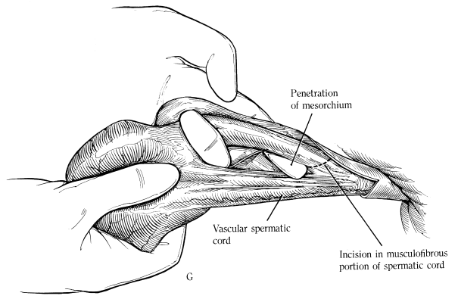
- Apply emasculator for short period to musculofibrous portion of spermatic chord and testis is then grasped and spermatic vessels are also emasculated. Emasculator is applied for 2 minutes.
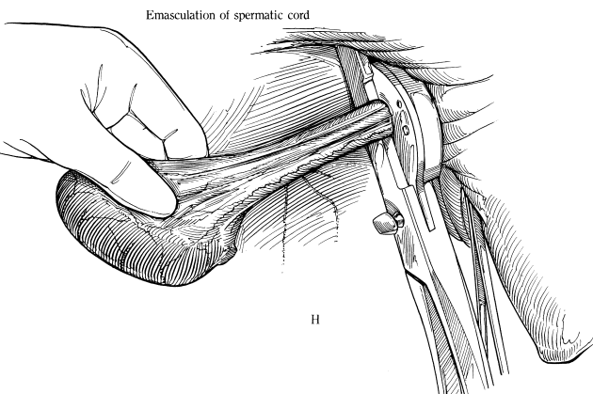
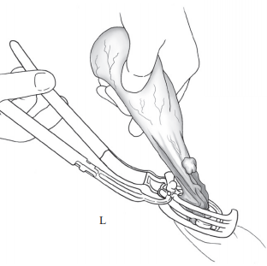
- LDS stapling device can also be used to reduce hemorrhaging by ligating the spermatic vasculature.
- Incision in skin is enlarged using fingers to pull apart until a 10cm opening is achieved. Median raphe is also removed to assist drainage.
- Any excess adipose tissue or facia is removed
- Repeat procedure for the other testicle

Resources:
https://aaep.org/sites/default/files/issues/476-482.pdf
https://veterinary-practice.com/article/a-history-of-castrating-2-000-equines
Turner and McIlwraith’s Techniques in Large Animal Surgery 4th Edition

