Signalment
Age: 5 years
Sex: male
Weight: 600kg
Routine physical exam was carried out and animal was deemed fit for procedure.
Preoperative
Ensure animal is healthy for procedure and that both testicles are descended.
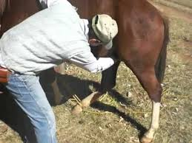
Anesthetic
Anesthetic regimen used is a mixture of xylazine at 1.0mg/kg and ketamine hydrochloride at 2.2mg/kg given intravenously.
For prolonged procedure, a second dose can be administered intravenously to achieve a desired length of time.
For a 600kg stallion, 6ml of xylazine and 13.2ml of ketamine is administered.
Restraint/ Positioning
The horse is cast in lateral recumbency and for right-handed person should be cast on left side for easier access. The upper hind leg, right hind leg for right-handed person is tied cranial.
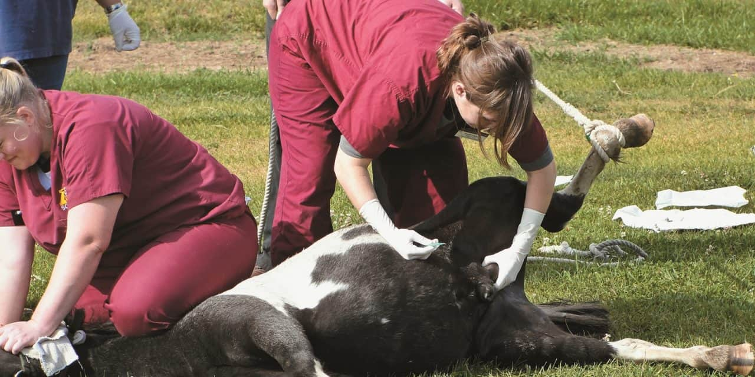

Alternatively, the horse can also be positioned in dorsal recumbency with hay or other soft material on either side to hold animal in place during procedure.
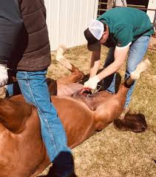
Surgical area is scrubbed with alcohol and iodophor solution prior to surgical procedure.
Intratesticular injection of 2% lidocaine hydrochloride, the dose of which may vary according to size of horse (typically 10–20 ml/testis).
Resources:
https://aaep.org/sites/default/files/issues/476-482.pdf
https://veterinary-practice.com/article/a-history-of-castrating-2-000-equines
Turner and McIlwraith’s Techniques in Large Animal Surgery 4th Edition

