https://www.youtube.com/watch?v=GOcJrgVazOY
The above video gives an overview of the various components of the male reproductive system of the Horse.
Vulva
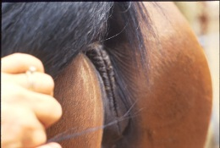
The vulva is the exterior opening to the reproductive canal. It consists of the labia, clitoris and the vestibule. The construction of this region is important because it serves to protect the mare from the entrance of air and other contaminants into the vaginal vault.
Vagina
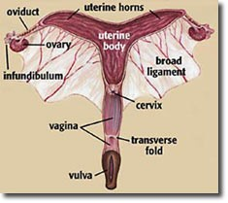
The vagina consists of a 6- to 8inch long muscular, mucus membrane lined tube which connects the vestibule of the vulva to the cervix. The vaginal tissues must be extremely elastic and distensible to accommodate the penis in breeding and the foal during birth.

Cervix
The cervix is a highly distensible muscle; approximately 4 inches long and appears as a circle of folded tissue at the anterior surface of the vaginal vault. Its shape and characteristics change significantly in response to the body’s hormonal environment. The cervix appears pink due to increased vascularity during estrus; a result of oestrogen production. During this period, it produces thin, watery mucus and is so relaxed that it is often found lying limp on the vaginal floor. This flaccid cervical tone facilitates passage of semen during live cover or breeding instruments with artificial breeding. In contrast, when the cervix is under the influence of progesterone during the diestrous period and pregnancy, it produces a thick, sticky mucus, and is tightly closed and held in the center of the vaginal wall. The physical barrier produced by a healthy cervix provides a major line of defense against uterine contamination and infection. Consequently, damage to this structure can result in significant problems in maintaining fertility.
Uterus
This is a multi-layered, hollow, Y-shaped organ. The base of the Y is called the uterine body, while the two branches are called the horns. The uterus is suspended within the body cavity by two tough, sheet-like structures called the broad ligaments. Sagging of these ligaments with age, parity or trauma can cause a downward tilting of the uterus. This conformation can predispose the mare to the backwash of urine into the reproductive tract and its accumulation at the cervix and can cause uterine infection and poor fertility.
Oviducts
Known as Fallopian tubes, the oviducts are small, highly coiled tubes. Each connects the tip of a uterine horn with an ovary. The ovarian end of the oviduct is called the infundibulum. It is enlarged and shaped like a catcher’s mitt with finger-like projections from its end called fimbriae. This conformation allows for the cradling of the portion of the ovary from which the ovum (egg) will emerge so that it can be captured and transported down the oviduct to the uterus. Fertilization of the ovum occurs in the oviduct where it narrows to join the uterus; this is called the isthmus. The oviducts are heavily lined with hair-like projections called cilia. The cilia and the muscular layers lining the oviducts work as a team to transport the ovum down the oviduct and for moving sperm from the opposite direction.

Ovary
Mare ovaries are unique both in shape and makeup. They are kidney bean-shaped and will have an obvious contrast in size and texture between the breeding and non-breeding seasons. During the breeding season they are functioning and about the size of a tennis ball. The convex side of the ovary is called the hilus and is the area of attachment to the abdominal cavity. The hilus also provides passage for blood vessels and nerves which serve the entire ovary. The concave side of the ovary is called the ovulation fossa and is unique to the mare. This wedge-shaped area is the only portion of the ovary from which an egg may be ovulated. The inner structure of the ovary consists of an outer area called the medulla and an inner part, the cortex. The cortex contains the ova; eggs. When a filly is born, the cortex contains all the eggs she will ever have. The cortex supports the growth and development of the structures on the ovary which help the eggs mature and also secretes hormones that help control the reproductive process.
Image of a vulva with good conformation

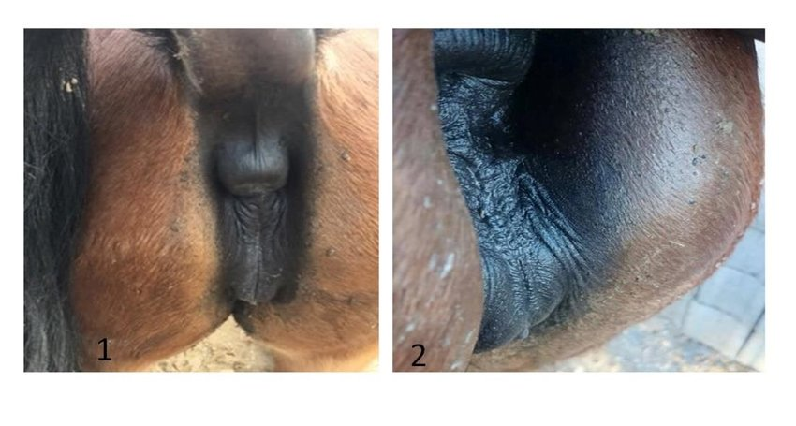
Image 1 shows a grade 1 on the Caslick’s Index with good vulvular confirmation. The vulva has a vertical confirmation which allows for a greater deal of protection to dust and faeces, that could carry pathogens; leading to uterine infections, infertility or subfertility. Image 2 shows grade 2 on the Caslick’s Index with moderate pneumovagina. There is an increased angle and the vaginal opening becomes oriented upward; leaving it exposed to dust and faecal matter which would lead to the above mentioned pathogeneses.

