https://www.youtube.com/watch?v=Nj9zXCkz--M
The above video gives an overview of the various components of the male reproductive system of the Horse
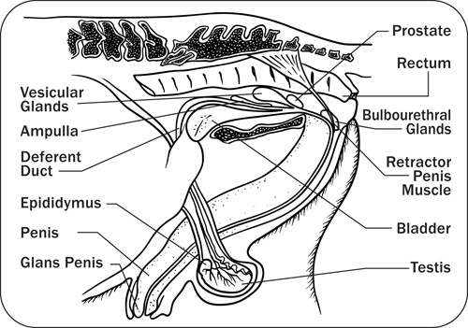

Accessory Sex Glands - These glands contribute fluids and gel to the ejaculate but are not key to fertility.

Vesicular Glands - The vesicular glands are accessory sex glands and add the gel fraction to the ejaculate.

Bulbourethral, Vesicular and Prostate Glands - These are accessory sex glands that add fluids to the ejaculate.

Deferent Duct - The deferent ducts transport sperm from the epididymis to the area of the accessory sex glands.

Epididymis - The epididymis transports sperm from the testes to the deferent duct and is the area for concentration, maturation and storage of the sperm.

Penis - The penis provides the means of penetration of the female reproductive system for semen deposition and is composed primarily of erectile tissue. The urethra is the tube that runs the length of the penis, conducting semen and/or urine to the outside.

Glans Penis - This is the sensitive end of the penis that enlarges during excitation and copulation.

Retractor Penis Muscle - This muscle retains the placid penis in the sheath and relaxes during erection.

Scrotum - The main functions of the scrotum are to protect the testes and maintain them at a temperature several degrees lower than body temperature.

Testes - There are two testes enclosed in the scrotum. The testes produce sperm cells and the male sex hormone testosterone. The testes should move freely within the scrotal sac and should be the similar size, shape and texture. It is found that the right is often slightly smaller than the left testes.

