Restraints for Horse Castration
Firstly, handling and restraint of the animal starts with the basics.
Physical Restraints:
Halter and Lead Rope; Always approach the horse on its left side and always make sure the animal is aware of your presence by speaking and lightly touching the animal. The halter should be securely placed on the head as shown in the video below. Additionally, get a guide from the owner as to how well the horse responds to handling.
https://www.youtube.com/watch?v=0CABQdO1XAg
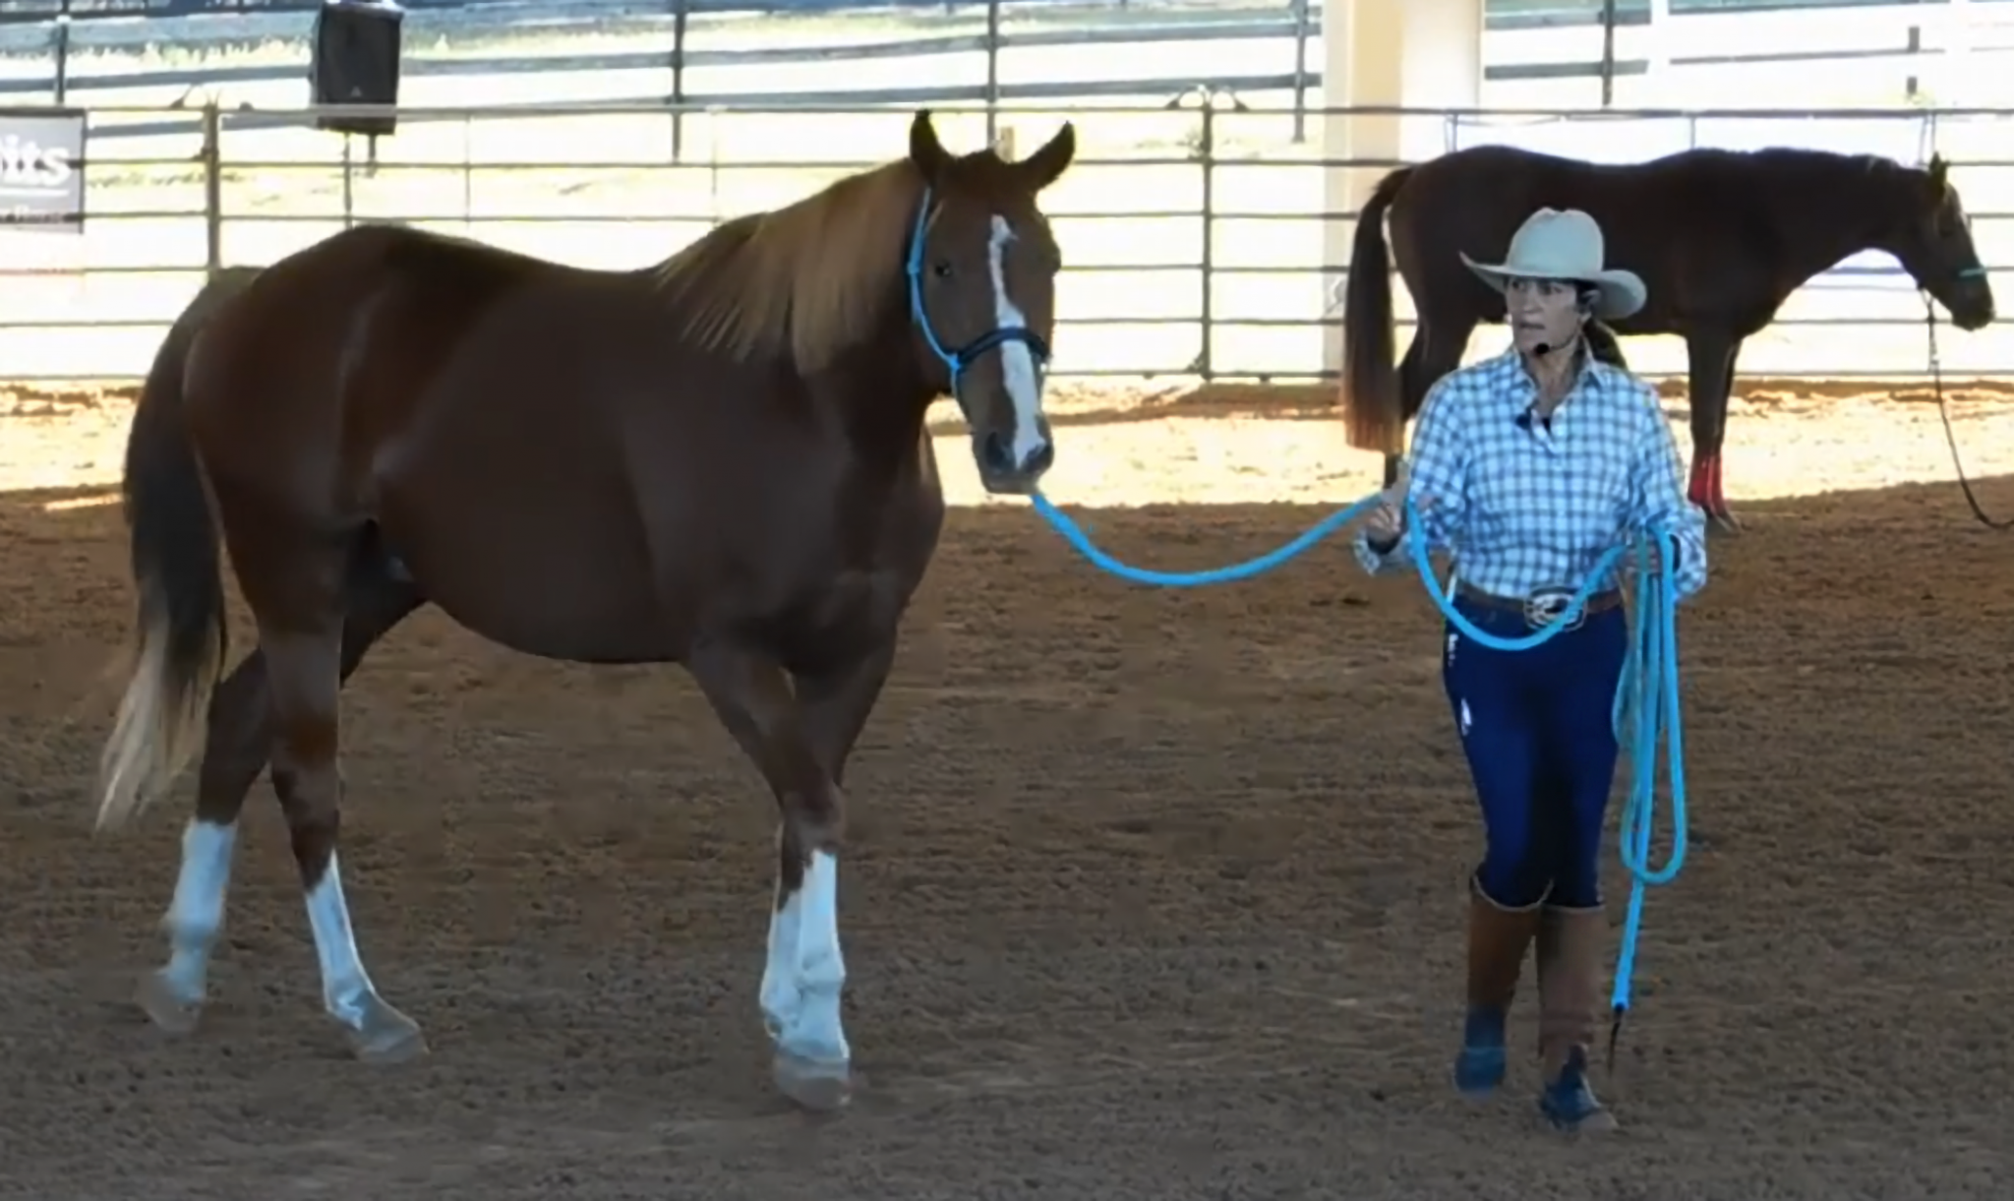

The methods of restraint mentioned in the videos below include the ‘shoulder roll’, ‘chain shank’, ‘lip chain’, ‘lead over the nose’, ‘crush’ and ‘twitch’. The crush is used for horses that are going to be examined per rectum; which includes examination of testicles. The twitch is ideally used as a last resort; and only for such time that chemical restraints can be employed to achieve a level of sedation that allows for a greater level of control and handling to examine the animal as well as to further induce the animal with general anaesthesia.
https://www.youtube.com/watch?v=n8ziukfKWxg
https://www.youtube.com/watch?v=j-FUd9odX9Y
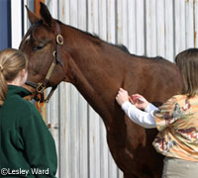 Shoulder roll
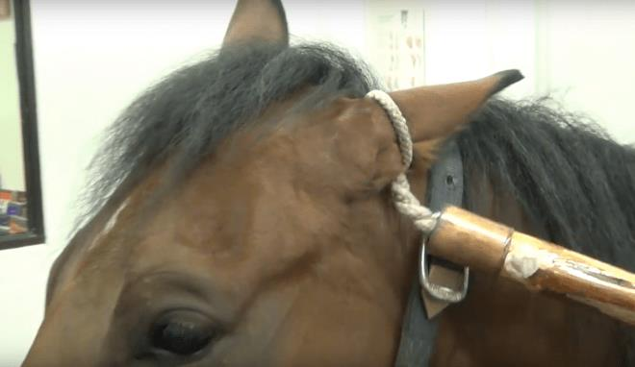 Ear twitch
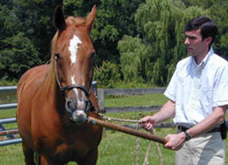 Nose twitch
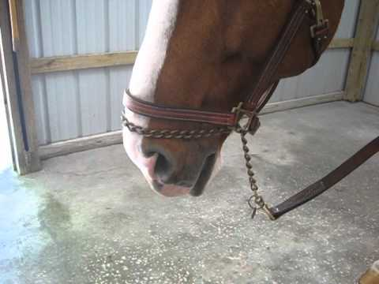 Chain Shank
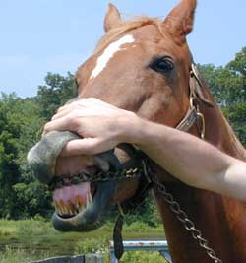 Lip Chain
Chemical Restraints:
For chemical restraints, detomidine hydrochloride or xylazine hydrochloride are used to achieve sedation. This allows for better handling the horse as well as easier examination of the horse. These drugs are often used in combination with butorphanol tartrate which provides reliable sedation and analgesia.

