CASE 3:
1.5-2yo male water buffalo that farmer wants to use for carting cane or pulling logs out of forest
Preoperative:
Before castration of the animal, the buffalo should be properly restraint. Proper restraint is especially important in this case because of the size and age of the animal. Without proper restraint of the animal the persons conducting the exercise would be at a high risk of injury. The animal should be placed in a cattle crush with its head properly restraint. A tail jack could be done also as another mention of physical restraint. It is important to know that the tail should be pushed up, and not twisted or bent. If the animal cannot be placed in a cattle crush the head could be tied tightly and the hindlimbs tied apart, to prevent the animal from kicking and to get proper access to the testes.

Instruments to be used in bloodless castration:
Emasculatome- burdizzo
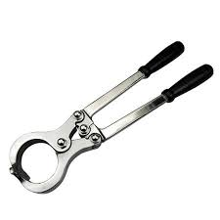
Banding using an elastrator 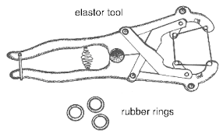

Based on the case, a bloodless castration technique should be done instead of an open castration. Performing an open castration would mean the animal would be prevented from performing its duties as working in the forest. The animal would be prone to fly strike, contamination and myiasis infection.

Animals should be vaccinated 7-10 before procedure, to prevent the risk of tetanus. This is done is bloodless methods of castration.

Local anaesthetic- 2% lidocaine
18-20-gauge 1inch needle

Xylazine can be used as a chemical restraint method as it would reduce the activity of the animal, making the situation a bit safer. It would promote proper animal welfare as it would reduce the amount of pain and stress experienced by the animal.
Xylazine- can be used as a sedative if the animal is excessively active. Dosage used 0.025mg/kg

The scrotum should be cleaned with an antiseptic (chlorhexidine, iodine, alcohol) to prevent contamination if there is a break in the skin.

Anatomy of the testes of a buffalo:
