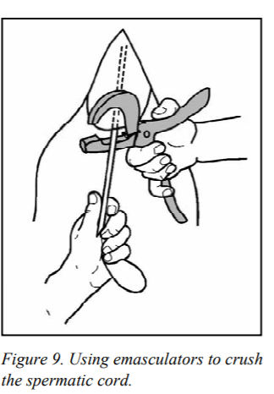
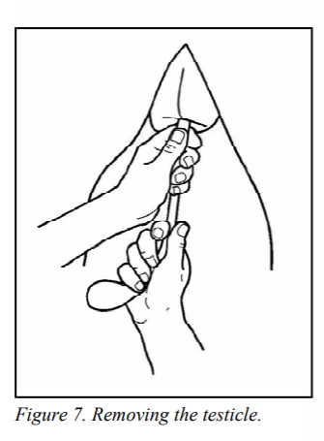
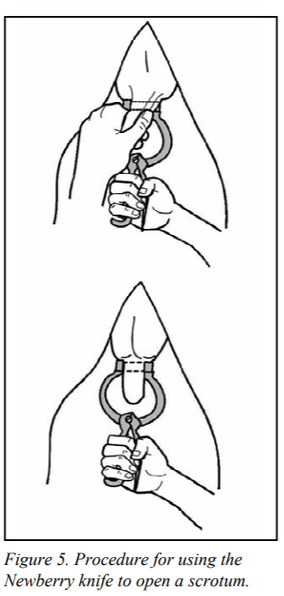

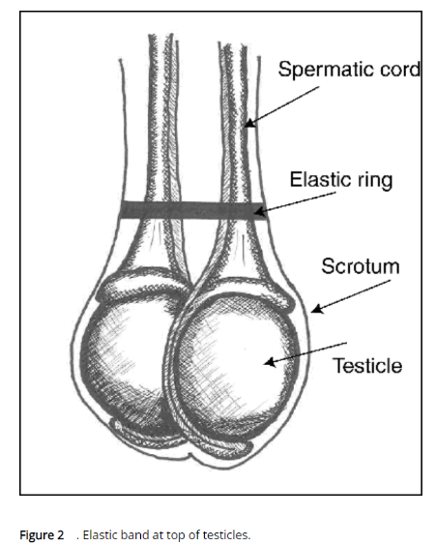
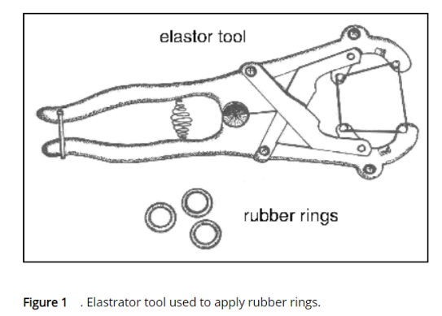

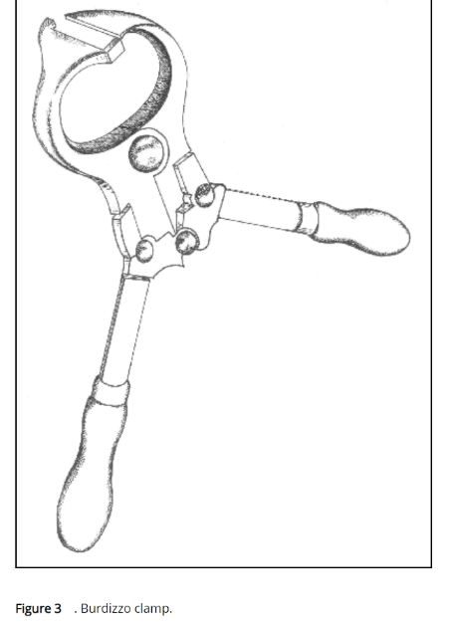
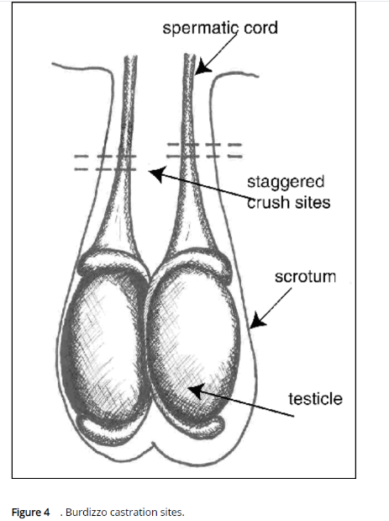

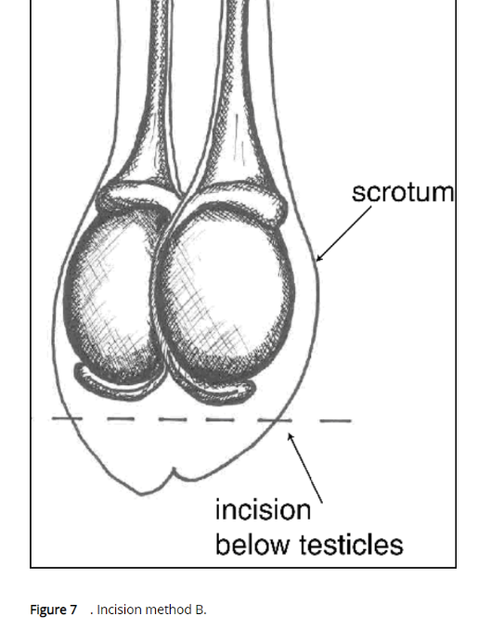

BIBLIOGRAPHY
- Anderson, N., 2015. Castration Of Calves. [online] Omafra.gov.on.ca. Available at: <http://www.omafra.gov.on.ca/english/livestock/beef/facts/07-029.htm#:~:text=Castration%20may%20be%20accomplished%20by,rings%2C%20Burdizzo%20or%20by%20surgery.>.
- Hopkins, F., Lane, C. and Gill, W., n.d. Castrating Beef Cattles. Agriculture extension service, the university of Tennessee. Available at: <https://extension.tennessee.edu/publications/Documents/PB1664.pdf>.

