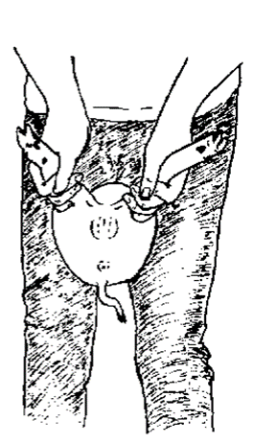
INTRAOPERATIVE MEASURES FOR CASTRATION

Castration of the male pig refers to removal of the testes. This is usually done with a nonsterile knife or scalpel. Castration is performed by first restraining a young piglet in some manner.
PROCEDURE:
- Clean the scrotum with warm water and soap and dry it
- If used, lidocaine anaesthetic is injected subcutaneously at site (explained further on preoperative measures)
- Move the testicle into the scrotum with your finger and then firmly grip the scrotum below the testicle between your thumb and index finger
- Make a cut 1 - 2 cm long in the bottom of the scrotum. The testicle should pop out through the cut. Haemorrhage is minimal at this age.
- Pull the testicle out of the scrotum and cut through the white cord leaving the red blood vessel uncut
- Pull the testicle out slightly further and twist it around several times before cutting the twisted blood vessel by scraping up and down with the knife. This helps to reduce bleeding. Do not pull to break the vessel. Ligation of the spermatic cord is recommended for older pigs
- Do not put your fingers in the scrotum. Apply either tincture of iodine, gentian violet, Dettol or an antibiotic powder a sulpha powder to the castration wound. Remove the second testicle in the same way
- Castrated piglets are placed under a heat lamp in the farrowing crate for convalescence

