Intra Operative Complications Disbudding of Saanen Goat At Age 2 Weeks
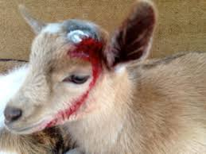
- There is always the risk of excessive bleeding but is very low if proper technique is used
- Animal welfare issues could arise if nerve block is not done; causing severe pain and physiologic changes in respiratory and cardiovascular function
- If the Electrothermal dehorning tool is not used properly and is kept for too long a period on the bud area; it is possible to burn to the brain

