Possible Complications
For Disbudding or debudding; removing the horn buds which are the germinal cells of the horns; the use of hot iron disbudding tool can burn too deep into the underlying bone. This can cause extreme pain as well as a greater chance of sinusitis.

Caustic chemicals some type of hydroxide chemical. Using such caustic materials are usually safe on both animal and handler. The major issue that can arise is if the material gets on the eyes or in the ears of the calf or the handler. To avoid this as best as possible; proper restraint must be practiced and be alert at all times.

For dehorning; where the horn has become attached to the bone of the skull; cutting of the horn by either using a dehorning spoon or tube, Barnes type dehorner or Keystone “guillotine” dehorner can be problematic if proper technique is not followed. If local anesthetic is not applied properly to the corneal nerve; there will be pain during the procedure which can endanger the calf and handlers.
Hemorrhaging is one of the complications that can be encountered during dehorning and can occur as a result of not using a tourniquet to stop blood flow or using cauterization properly to seal blood vessels.
Either situation can go terribly wrong and incur animal welfare implications if analgesics and anesthetics are not used or not used properly. If a nerve block is not done properly, the animal will experience extreme pain.
During cosmetic surgery dehorning, hemorrhaging is dangerous if the corneal artery is not ligated properly.
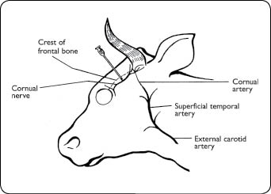
When dehorning is done incorrectly - https://www.youtube.com/watch?v=8nGMgHyzHcA
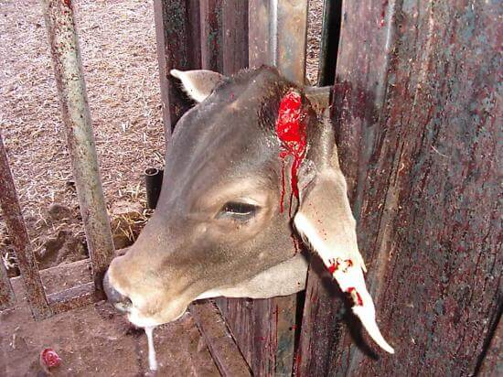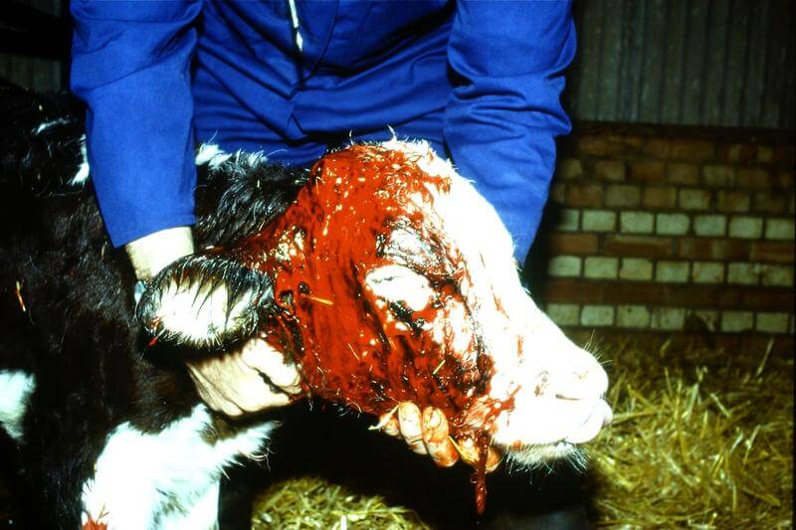

Tourniquet to prevent bleeding https://www.youtube.com/watch?v=CpoEppBJ9KM
Surgical (cosmetic) dehorning https://www.youtube.com/watch?v=lzHucPPEgNs

