Intra Operative complications for Cosmetic Dehorning in 2 Year Old Boer Ram
Disbudding in goats are usually done within the first two weeks.
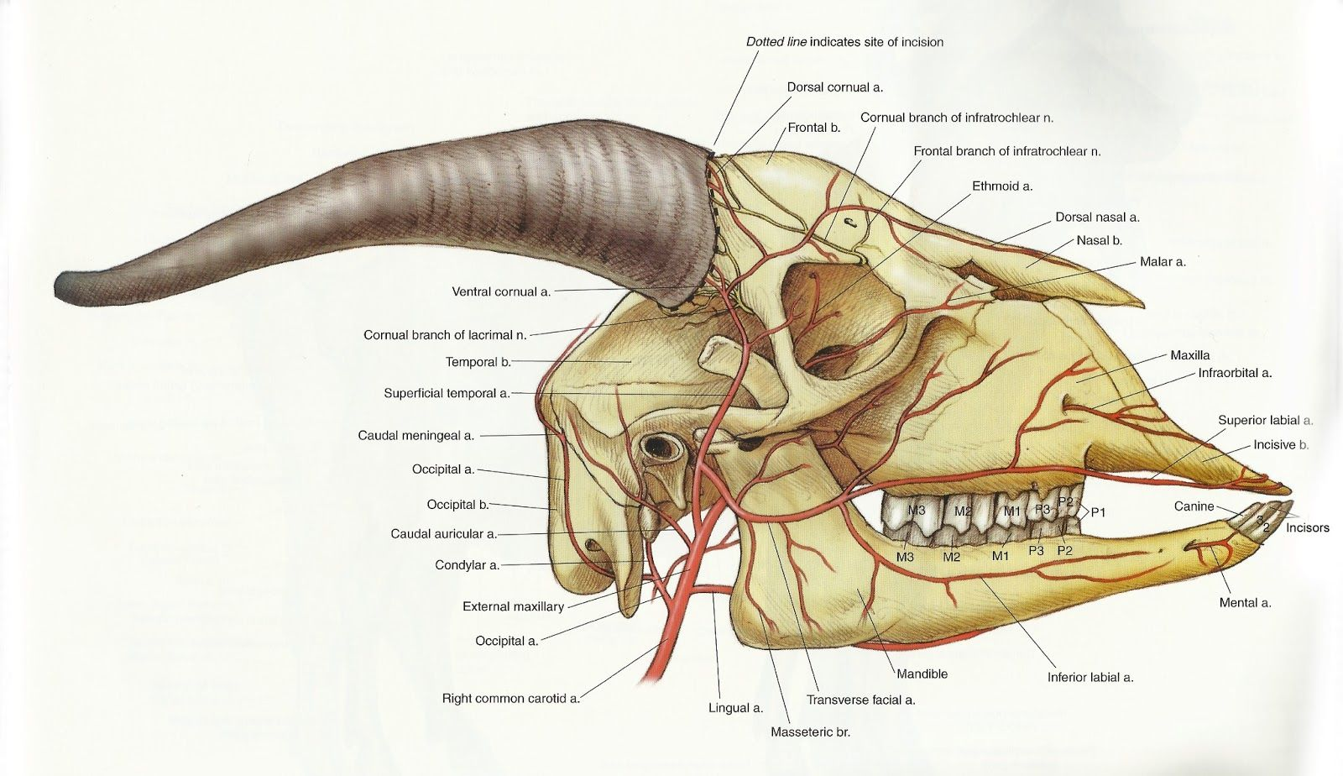
In this case the Ram is two years old and aggressive. The owner wants to have an aesthetically pleasing appearance post procedure so cosmetic surgical removal of the horns should be done. The goat is a Boer which is commonly used for show.
Xylazine has fewer side effects and may possibly cause bradycardia and respiratory depression. This is rare.
Lidocaine toxicity is possible if care is not taken to aspirate and ensure the needle is not in a blood vessel.

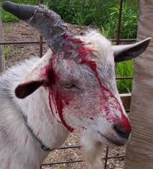
Banding could result in excessive trauma to animal
In the case of this ram cosmetic dehorning would be the most likely choice.
https://www.youtube.com/watch?v=e_61mYwdK1A
Complications
- With any procedure involving incisions there is always the possibility of excessive bleeding if care is not taken to avoid major blood vessels as well as if blood vessels that are cut are not ligated properly.
- Some cases there may not be enough skin to close the incision
- Because the horns may be so close to each other the incisions may communicate with each other

