NEVER BLOCKING FOR DEHORNING
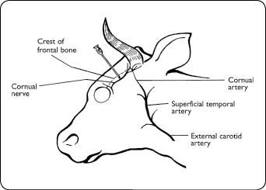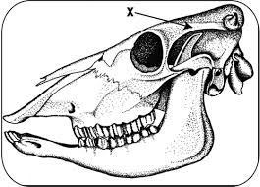
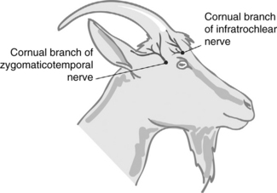
The nerve supplying the horn is known as the cornual nerve, it travels from immediately behind the eye to the base of the horn and lies underneath a small overhanging ledge of bone that is a connected to the skull. This ledge is easily detected with slight finger pressure. A vein and an artery are found in association with the nerve. In order to perform a dehorning, blocking the nerve makes the procedure easier on the calf and on the person doing the job. You must block one nerve on each side of the head using a Lidocaine anesthetic which is a prescribed drug.

The link below shows a video on how nerve blocking is done in cattle
https://www.youtube.com/watch?v=gc1bTa9coUM

Procedure:
- Restrain the calf with a halter tied to a ring, a post, or the head gate of the chute.
- Preferably, sedate the calf with an injection of an appropriate dose of a sedative and a non-steroidal anti-inflammatory drug as per label directions.
- Locate the injection site (Figure 1) for the local anaesthetic by putting your thumb on the skin just beside the outside corner of the eye. You will feel a soft depression at this site. Now, move your thumb backwards toward the horn. You will feel a small groove that runs in the bone of the skull. The nerve runs along and under this groove. The injection site is in the upper third (closer to the horn bud) between the corner of the eye and the base of the horn.
- Disinfect the site with an alcohol swab.
- Use a 20- or 18-gauge, 1 to 1.5 inch needle.
- Use a 6 or 10 cc syringe.
- Use from 3-10 cc of 2 per cent lidocaine with epinephrine for each horn. The volume depends on size of calf.
- While holding the head steady and with the needle on the syringe, push the needle through the skin at the injection site. The needle should penetrate perpendicular to the skull at the site. Once you are through the skin, pull back on the plunger to be sure the needle is not in a blood vessel; then inject about 1.5 cc of lidocaine. Push the needle in about 0.25 inches and inject another 1.5 cc. Push it in about another 0.25 inches and inject the remaining lidocaine. Then withdraw the needle. If you hit the bone with the tip of the needle, withdraw it slightly and give the last of the lidocaine.
- Repeat on the other side of the head. The lidocaine is similar to the product used by dentists to freeze your tooth.
- You may need to wait several minutes for it to take effect. The upper eyelid usually droops with correct injection techniques. Failure may occur if the injection went too deep at the site.
- Proceed to block the nerves on other calves and then return to dehorn the first calf.

