Drug name | Category | Use | MOA | Dose | Method of administration | Side Effects | Withdrawal times | Precautions
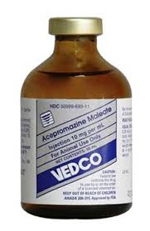  Acepromazine | Phenothiazine sedative/ tranquilizers | Tranquilisation during shipment  Sedation of nervous or aggressive animals  Premedication in general or local anesthesia  In dogs and cats used to alleviate itching as a result of skin irritation | Block postsynaptic dopamine receptors in the CNS,  Inhibit release of and turnover rate of dopamine | Horses,cattle  IV: 0.25ml(5mg) per 100kg b.w  IM: 0.25 -0.50 ml (5-10mg) per 100 kg b.w.  Pig,sheep,goat:  IV: 0.1ml (2mg) per 10kg b.w.  IM 0.1 to 0.2 ml (2-4mg) per 10kg b.w.  Dog,Cat:  I.V: 0.2ml(4g) per 10kg b.w.  I.M: 0.2 to 0.5ml (4 to 10mg) per 10 kg b.w. | IM,IV | Hypotension,cardiac rate abnormalities, hypo or hyperthermia  Penis protrusion in large animals (esp horses) | Slaughter: 5 days  Milk delivery: 2 days | Inject IV slowly,do not inject into arteries

