**Eyelid Laceration Repair (V-Plasty)**

This procedure is to correct traumatic injury causing severing at the eyelid margin(s) or resolve growths and neoplasms on the upper or lower eyelid. The aim is to, where applicable, carefully remove the growth and then performing suturing that allows for optimal apposition of the cut surfaces of the laceration/resection incision. This yields much better healing, preventing any inner folding of any portion of the eyelid upon blinking, as well as a satisfactory cosmetic effect.

In resection, it is key to note that there must not be no more than 2/3 of removal of eyelid tissue laterally nor vertically/ventrally on the respective eyelids. This ensures there is still some acceptable degree of function without discomfort post-operatively.

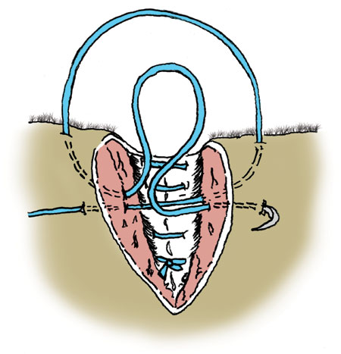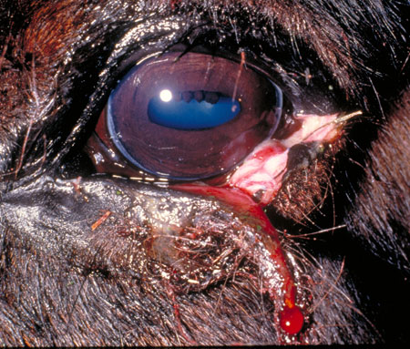

**Appropriate apparatus and materials:**

- Xylazine

- Ketamine

- Lidocaine

- Clippers

- Sterile gauze

- Cotton swab applicators

- Mayo scissors

- Scalpel handle with blade

- Povidone iodine

- Sterile saline

- Flunixin meglumine

- Penicillin-streptomycin

- Tetanus antitoxin

- Clippers

- Haemostats

- Surgical drapes

- Suture material with suturing needles (e.g. 3-0 Vicryl)

* The patient is sedated using an appropriate dose of suitable anaesthetic agent to bring them to a slightly neurologically depressed state, making it somewhat easier to work.
* The area around the eye is clipped carefully to remove hair that can potentially contaminate the surgical site and the loose hair is blotted off with moist gauze.
* The skin around the eye is properly cleaned using sterile gauze soaked in diluted povidone iodine, alternating with sterile saline. Only dilutions of 1:10 – 1:50 are acceptable.
* The eyelashes can also be clipped using Mayo scissors lightly lubricated in order to prevent any clipping falling directly into the eye.
* The eye is then surgically draped.
* In order to prevent drying of the cornea of the affected eye, sterile saline or methylcellulose gel can be applied.
* Broad spectrum antibiotics e.g. pencillin-streptomycin can also be administered prior to surgery in order to prevent the onset of post-operative infections.
* Flunixin meglumine can be administered at 1mg/kg IV for anti-inflammatory therapy.