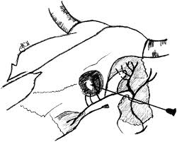**Peterson’s Nerve Block**

Desensitizes structures in the eye allowing for major surgical procedures. This nerve block requires the skill of trained veterinary practitioners as it requires a great deal of precision in order to place the local anaesthetic at the right location for maximum effect.

**Indications**: conjunctival flaps, exenteration of the eye, extirpation, other major ocular operations

**Blocks the following nerves:**

* ophthalmic branch of CNV innervating upper eyelid, third eyelid, median canthus and eyeball, the oculomotor
* trochlear and adbucens nerves supplying innervation to the muscles allowing for movement of the eyeball
* maxillary branch of CNV supplying the lower eyelid
* the mandibular branch of CNV.

**Appropriate apparatus and materials**:

* 10cm 90mm spinal needle is best for arriving at the exact location for the delivery of the anaesthetic agent
* 20mL disposable syringes
* 0.5% Lidocaine

**Safety considerations**:

It is imperative that the patient should be sedated to minimize the risk of damage to the gross structures of the eye (particularly the globe). While there may be decrease in general movement of the animal, the clinician must still be aware of the animal’s behaviour during application of the block.