**Subconjunctival Injection**

A method of drug administration into the dorsobulbar conjunctiva of the eye for relatively slow but direct delivery in the treatment of localized infections e.g. treatment of infectious keratoconjunctivitis in bovine species, dilation of the pupil, treatment of corneal ulcers or post-operative delivery of antibiotics after surgery on the eye. This would also help in providing additional medical treatment in the event that the patient has already been subjected to topical drugs and is not allowing for further application due to its temperament.

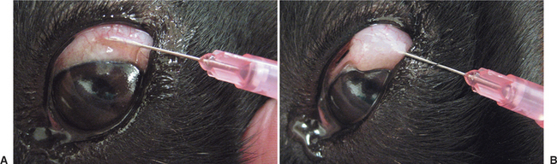

**Appropriate apparatus and materials:**

* local anaesthetic drops
* sterile 1ml or 2 ml syringe
* prescribed medication
* sterile 21G needle
* sterile 25G needle
* clean cotton wool or gauze swabs.

Ideally, the patient should under **sedation using a suitable agent e.g. xylazine/ketamine** to decrease the likeliness of sudden movement in response to the insertion of the needle into the sensitive tissue of the conjunctiva.

It is important to note that **only very small amounts of medication** can be given at any one time. For most adult cattle, this would range from ½ - 1mL with no complications while in small ruminants, only ½ to ¾ mL can be given in the subconjunctival tissue.

Subsequent to the administration of the medication, an **eye pad** secured to the periocular skin with medical tape and covered with a bandage should be applied over the eye. This is to prevent any trauma being brought to the eye as the unusual swelling may be uncomfortable to the patient, causing it to rub the face on hard surfaces causing rupture of the bleb formed.